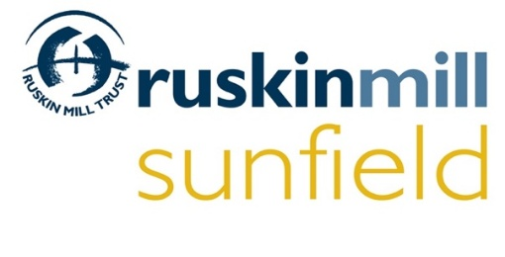

Sunfield Garden School and Children’s Home sustains a distinguished historical legacy, set in 52 acres in the beautiful Clent Hills, West Midlands. Sunfield’s farm, walled garden and woodlands provide excellent opportunities for outdoor learning and practical activities. Sunfield is part of Ruskin Mill Trust.

Established in 1984, Ruskin Mill Trust is an educational charity that operates in England, Scotland and Wales.
We offer exciting outdoor learning environments, utilising practical land and craft activities to support the development of work and life skills in young people with autistic spectrum conditions and other learning differences. Our research-led method, Practical Skills Therapeutic Education, is inspired by the work of Rudolf Steiner, John Ruskin and William Morris. Working with hand, head, heart and place, Ruskin Mill Trust helps individuals to re-imagine their potential.

The Trust is committed to safeguarding and promoting the welfare of children and young people and expects all staff and volunteers to share this commitment. Successful applicants will be required to undergo a Disclosure and Barring Service Enhanced Level Disclosure as well as a medical check, references, evidence of qualifications, plus verification of the right to work in the UK.

Deputy Farm Manager
40 hours/52 weeks

Salary Range - Grade 10 £34,712 to Grade 12 £43,404 dependent on qualifications
(Grade 11 with QTS and Grade 12 with QTS and Biodynamic Qualification)

This is an exciting opportunity offered by Sunfield for a Deputy Farm Manager. The post holder will support the running and ongoing development of Sunfield’s biodynamic farm and land in collaboration with the Executive Principal and the Biodynamic Land Manager. The Deputy Farm Manager role will support with the care of livestock, pasture and farm landscape; plan and lead sessions with students relating to animal husbandry and land work; support the Biodynamic Land Manager in biodynamic practice and culture in all areas of the life of the provision; and support the growing and production of small scale biodynamic arable crops.

The key duties in this role will include:
- To support the day-to-day running of the farm and to organise appropriate work for students and volunteers.
- To work with biodynamic (BD) principles and methodologies and integrate them into all aspects of the operation of the farm and wider provision to promote the biodynamic work carried out to all staff and any visitors to the site.
- To deputise for the day-to-day farm management across the site in accordance with current Demeter Standards and to provide regular feedback reports to the Biodynamic Land Manager.
- To provide teaching and learning opportunities and to ensure that the curriculum offered and delivered is in line with the method of the trust and the individual needs of the children and young people.
- To support the health and welfare of all stock on the farm, which includes livestock breeding, rearing and finishing.
To undertake this role successfully you will have:
- Experience of animal husbandry, to at least a small holding level and demonstrate a strong willingness to learn.
- A good understanding of biodynamic and / or organic farming principles.
- Experience in leading groups in land-based work.
- A strong interest and passion for enabling young people with complex needs; including Autism, to learn and develop.
- The ability to plan and deliver educational activities in a manner which is stimulating, engaging, enjoyable and inclusive.
- A recognised Biodynamic training / equivalent experience or the motivation to undertake Ruskin Mill Trust’s accredited biodynamic training.
- A teaching qualification of L4 or above is desirable.
- A full driving licence with access to a vehicle is desirable.
Working at Ruskin Mill Trust is incredibly rewarding; we offer competitive salaries and holiday allowances, an auto-enrolment pension scheme with a salary sacrifice option, a health cash plan and employee assistance programme via Medicash.

In addition, staff receive valuable training opportunities including an in-depth interactive induction to enable our new team members to experience our Practical Skills Therapeutic Education (PSTE) curriculum and also opportunities for further training and academic research including our own MSc in Practical Skills Therapeutic Education.

Full details of our benefits can be viewed on www.rmt.org/careers

