Communications Coordinator (17.5 hours per week, permanent) 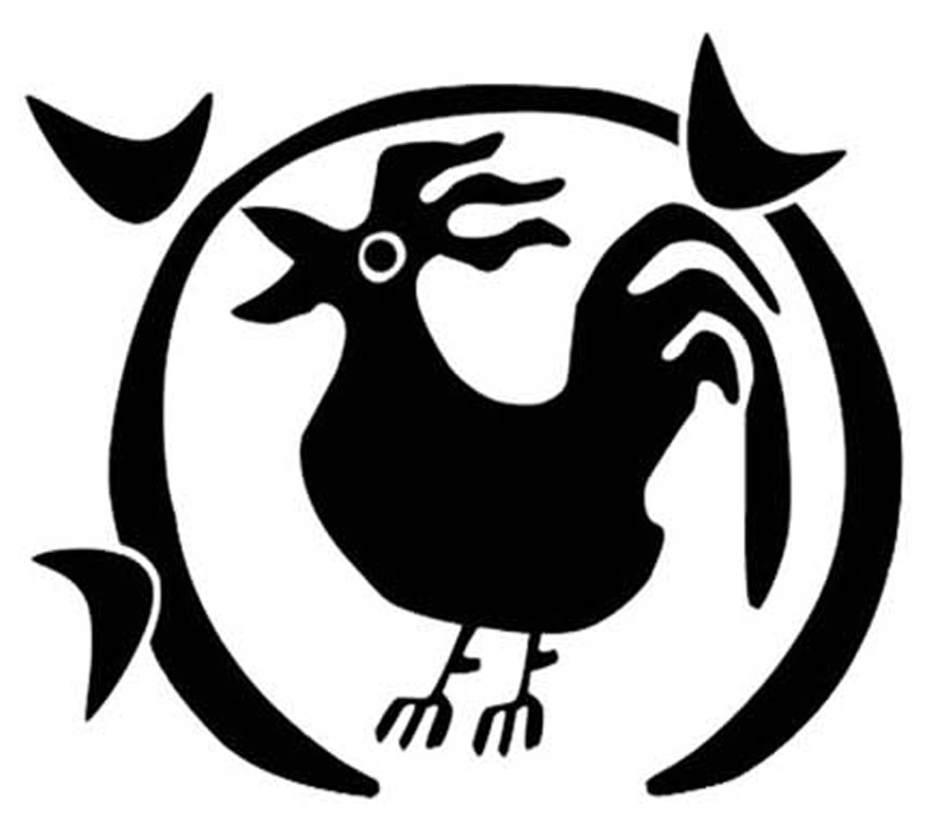
Working days and hours can be agreed on a flexible basis but hours will need to be spread across a minimum of 3 days per week.

Welcome to the Farm
St Werburghs City Farm is a small charity that uses our unique nature sites as a launchpad for community projects that reach over 3,500 people every year. All our work is based in nature and farming, with the aims to improve physical and mental health, offer green skills learning opportunities, and increase community connection. We are a working Farm that produces meat, eggs, vegetables, plants and crafts.

Our core programme of community projects exists to serve:
- children struggling in mainstream education or experiencing marginalisation
- adults with learning disabilities
- adults experiencing mental health challenges.

And our wider communities benefit from our events and free-to-enter urban Farm, which invite 60,000 people each year to connect, celebrate, and enjoy inner-city nature sites.

Our sites include:

- A small urban Farm with livestock and vegetable patches
- A café (which we lease to a company) and popular playground
- A community garden on Mina Road
- Boiling Wells Woodland Conservation and Amphitheatre site, on Boiling Wells Lane
- 230 community allotments

Access to green space is not equal, and the Farm is committed to addressing this inequality. The Farm’s EDI strategy was created in collaboration with our communities, and is central to our work and decision-making as a team. We cherish our diverse neighbouring communities and all the skills, perspectives and energy they bring to the Farm through our regular community consultation and engagement work. We recognise the Farm’s responsibility to continually improve and learn to become more equitable.

We are working to create a future where communities connect, green spaces flourish, and together we thrive.

What you will love about working here
- Working in a supportive environment which values your diversity and talent.
- Access to training opportunities and reflective practice.
- Being part of a welcoming team that strives for greater inclusion and equity.
- Flexibility for those with families and other commitments.
- An office based at the Farm, surrounded by allotments. A beautiful, green community setting.
- Generous annual leave entitlement – 25 days and bank holiday pro rata.
- Participation in the NEST pension scheme.
- Access to the cycle-to-work scheme.
- Opportunity to pop outside and say hi to a goat!

About the role
We’re looking for someone who wants to join our busy charity to make a real, meaningful difference to communities in Bristol. With a demonstrable track record of producing accessible, high quality digital and print materials, managing websites, and running multichannel campaigns. You will connect people to our cause through telling the vibrant story of the Farm and our projects. If you’re a passionate storyteller with great organisational and people skills, and care about community wellbeing, we’d love to hear from you.

Your role will include a range of activities, including:
Strategy & Planning
- Develop the Farm’s Communications Strategy with support from the Fundraising Manager, supporting the team to set priorities and timelines
- Prepare a high-level annual plan for delivering the Communications Strategy
- Champion equity, diversity and inclusion and ensure that messaging across our digital communications and physical spaces is inclusive, welcoming and accessible.

Newsletter & Social Media Content
- Work closely with the Fundraising Manager to develop multichannel content that supports our Communications Strategy and engages our supporter audience.
- Manage a clean, segmented mailing list and develop targeted email campaigns for a variety of audiences.
- Collaborate with project managers to understand what’s happening across the Farm, identify impactful stories, and develop inspiring and informative content about the What, How and Why of the Farm.
- Collaborate with the Events Manager to promote our seasonal events programme and other community offerings.
- Support income generation through driving ticket sales for events and leading the promotion of our weddings offer, events partnerships and other products/offerings.
- Manage and respond to enquiries via social media messaging and comments, and the Communications inbox.

Website
- Manage and streamline the Farm’s Wordpress website, to ensure content is user-friendly, clearly shares our opportunities, and inspires people to support our work.
- Keep the website up to date with new content, liaising with the team where appropriate.
- Work with our Office Manager to update our low-maintenance e-commerce page.

Print & Design
- Design and produce compelling materials to promote our opportunities, offers and events.
- Produce informative, educational and inspiring signage for our sites to improve our visitor experience and impact.

Your skill set
- Experience creating written and visual content for a range of channels, in particular Mailchimp and Instagram.
- Excellent written communication, the ability to identify good stories and educational pieces, and translate complex topics into clear, engaging and impactful messages.
- Ability to design visually compelling, accessible graphics using Canva.
- Ability to strategically plan communications throughout the year, reflecting organisational priorities and key dates.
- An awareness of fundraising practice in the charity sector and supporter stewardship.
- Experience supporting income generation and fundraising income through communications.
- Ability to develop content for, and manage, a Wordpress website, including e-commerce.
- Excellent interpersonal skills with the ability to collaborate with a diverse, multidisciplinary team.
- Ability to tailor information to different audiences, including visitors, participants, donors, local businesses, and other stakeholders.
- Confidence to take ownership of the ‘voice’ of the Farm.
- Knowledge of the charity sector and understanding of the need for values-led communications.
- Understanding of the power of language and visual storytelling, and a commitment to harnessing phrases / messages / imagery that connect and inspire people, rather than alienate and exclude.

Your approach
- Commitment to learn new skills, be reflective of your work and willing to adapt
- Strategic and organised, able to bring together lots of different components into a clear vision
- Commitment to inclusion, equality and accessibility
- Ability to collaborate as part of a team, delegate responsibility and communicate priorities
- Ability to manage personal deadlines and prioritise a demanding workload
- Strong interpersonal and communication skills; professional, personable, approachable and responsive
- Reliable, pro-active and self-motivated and ability to think creatively
- Passionate about the Farm's vision, mission and activities

Other details
Contract type: Permanent
Salary: Starting at £25,119 pro rata, rising to £26,873 pro rata
Hours of work: 17.5 hours per week. Usual working ours will be between 9 - 5pm, Monday to Friday, with occasional evening and weekend working required to support delivery of events.
Place of work: This role is based at St Werburghs City Farm in Bristol, with options for hybrid working.
Line Manager: Fundraising Manager (Operational)
Annual leave: 25 days holiday per year, plus public holidays, pro rata
Probationary period: The appointment will be subject to a probationary period of 3 months.
References: All appointments will be confirmed only upon receipt of satisfactory references.
Application Deadline: 10am Monday 19th January

The successful candidate will be required to undertake a DBS check for this role. If you have any questions or would like an informal chat about the role, please email: director@swcityfarm.co.uk

