Case Study:
Bangor Healing Garden
Bangor, Gwynedd February 2020

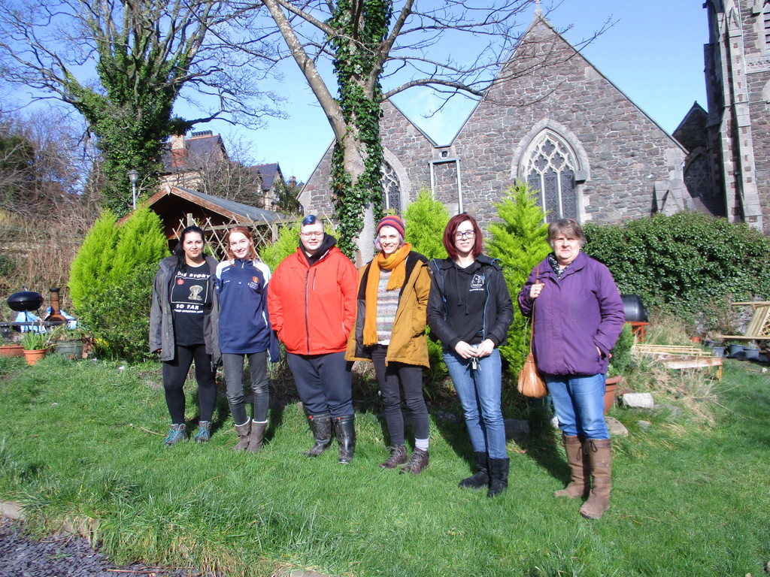
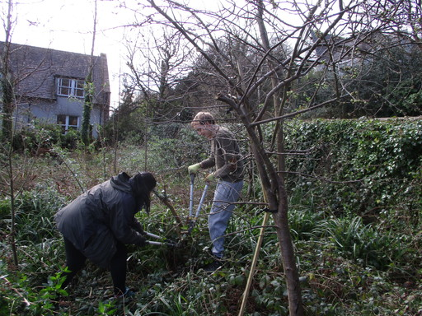 | 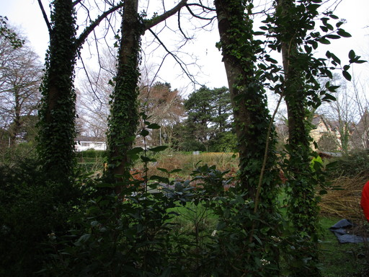 | 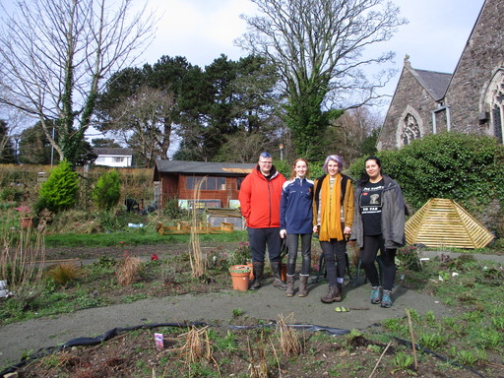

Background
The site of this garden is part of the Bangor University estates and is a quarter hectare situated right in the town of Bangor next to St James’s Church. It used to house two town houses which were demolished in the 1980s. The area remained derelict and full of rubble until 2008 when a group of students were looking for a place to make an organic garden, to grow some veg and meet, chat and work together. Eventually the garden was recognised by the University Estates and permission was given to continue gardening there. The garden was somewhat sporadically managed due to the inevitable turn over of university students with periods of falling into gentle neglect.
It was in one of these periods that Emily Davies volunteered to take on the running of the garden three years ago. Emily has provided some much needed continuity and the garden is now in a period of development.
Recent developments in the garden
In response to a rumour that the land could be sold along with a nearby building the group lobbied their University Estates department to secure it. They were eventually visited by the Vice Chancellor who guaranteed to keep the land for at least the next five years.
With this reassurance in 2019 the group became the Healing Garden Volunteering Project and now has a core of 20 regular volunteers and many more turning up for events.
This small, town centre space is packed with diversity providing different habitats and plantings. The original vegetable beds are being renovated and turned into raised beds. The bank up to the road on one side has been cleared of most of the weeds and bramble and, after assessing what is already there, some choice sun lovers will be added in. The willow hedge above it provides shelter for the wildlife and weaving material for the group.
There is an orchard with a dozen or so fruit trees (including a fig) and storm damaged trunks are lovingly grafted and bandaged. There is a shrubbery with butterfly attractors and a wild area with mature trees, ivy groundcover and under-storey shrubs. A shady seating area with fire pit provides a space to enjoy the pizzas cooked in the pizza oven built from a kit found abandoned at the back of the shed.
With some funding from Grow Wild they have been able to improve access for wheelchairs and sow a wildflower area.
In 2018 they were approached by Headway, a brain injury charity in Gwynedd, to form a partnership. Headway had been looking for a garden to use as an outdoor healing space for people recovering from brain injury. The student volunteers have welcomed this development and together they have created a Healing spiral planting with plants that appeal to all five senses. Recovering patients will use the garden as a place to re calibrate their senses as well as for mindfulness and contemplation.
Activities
Everyone is welcome at the garden and they hold a regular workday each week but volunteers can come any time. They have held activities for local schools and cubs as well as creative clay workshops, pumpkin carving and a very successful Christmas meal using some of their own produce. They also have close links with the Treborth Botanical Garden and volunteer there once a month. The curator of Treborth visits them, too, and is generous with advice and support.
The garden is used as an outdoor laboratory for the students. They can develop field and identification skills and it is popular with the entomology and zoology students.
Bangor University operates an employability points scheme which rewards volunteers in the garden and enhances their cv.
The future
The Healing garden group are keen to add a therapy shed for the Headway patients and it is hoped that the garden will also be used as an outdoor occupational therapy space. They also have their eye on a nearby disused phonebox as a possible greenhouse!
The group are working with Aberystwyth University to hold mindful yoga workshops and their hopes for the future are to develop even better links with the local community. Their challenge is to ensure the continuity of the group as students inevitably move away.

