Golygfa Gwydyr

Llanwrst, Conwy February 2020
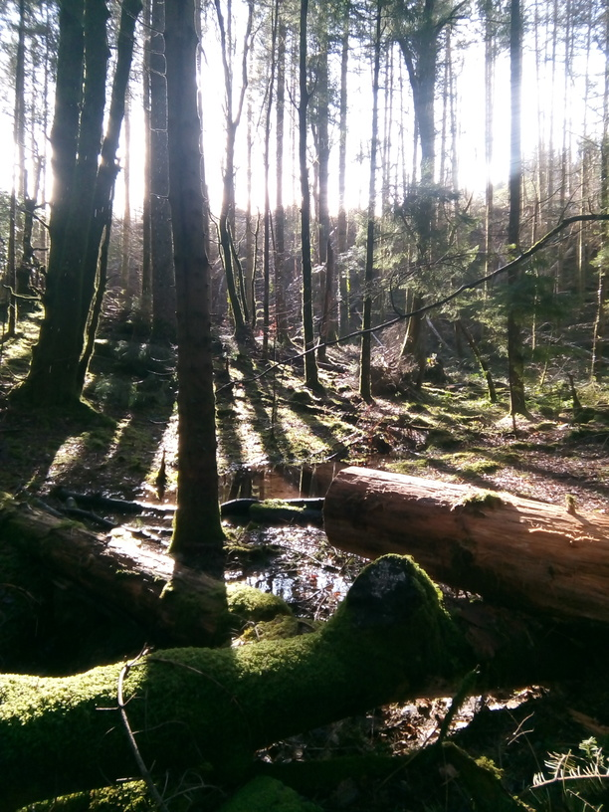

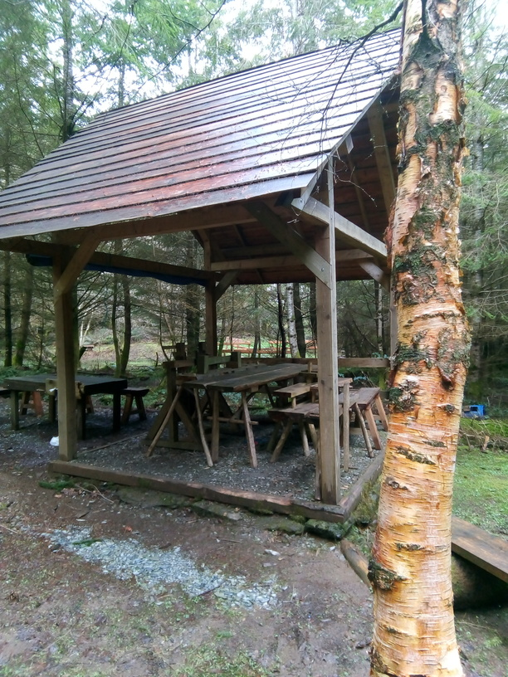 | 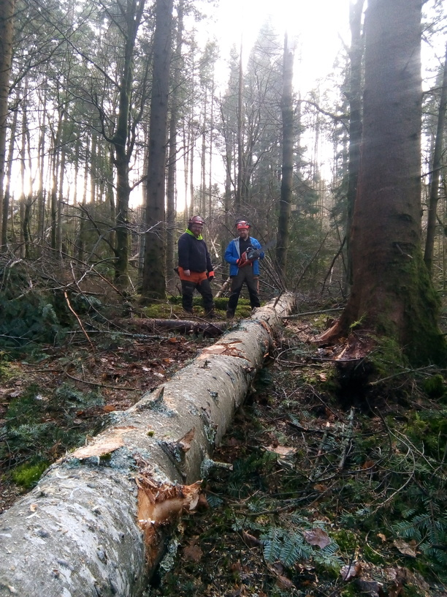 | 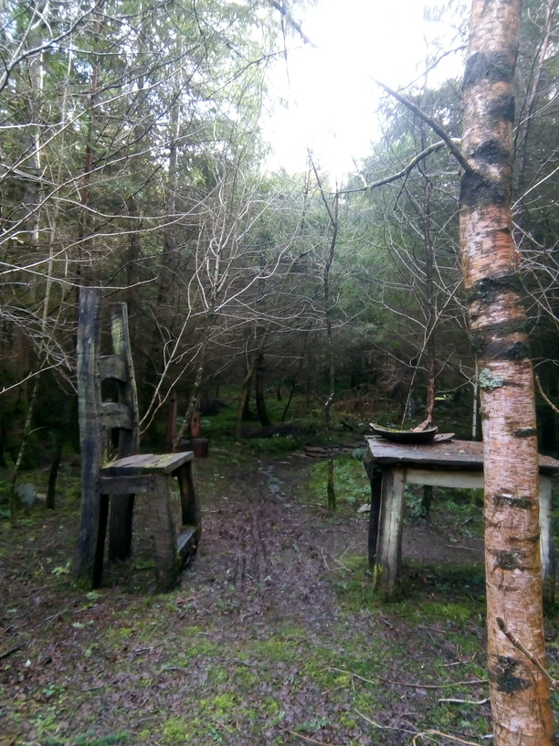

Background information
The Gwydyr Forest Park extends to over 28 sq miles of plantation forest between Llanwrst and Betys y Coed in Gwynedd. The forest is mixed coniferous and has provided employment and resources for the near by towns since its beginnings. In the 1950’s a farm on the edge of the woods was relocated to make room for the trees needed to supply a growing requirement for timber.
The forest is now a leisure facility for both tourists and locals with extensive bike routes, and well marked walking routes as well as a commercial plantation managed by Natural Resources Wales .
In 2004 a group of forest residents came together to oppose the building of 100 cabins on the shores of Llyn Parc in their forest. The group disbanded after the success of their protest but the power of a committed local group had been ably demonstrated.
Start up
Realising the potential of the forest as a community resource a number of residents around the Gwydyr forest were considering how best to secure a portion of the woods for community use. They were approached by Theatr Cynefin, an outdoor theatre group who wanted to make a labyrinth through the forest and the social enterprise Golygfa Gwydyr Ltd was formed.
The group then started negotiations with Natural Resources Wales to find a site suitable for the outdoor theatre and make the mile long labyrinth. They were eventually offered 11 hectares of forest covering the site of the old farm house where a few ruined walls remain and (unbeknownst at the time) the original well.
The performances have been successful to the point that advertising is not really needed! It is a mindful and personal experience guided by the actors and volunteers as you make your way through the magical woodland labyrinth.
The management of the trees on the site was taken on by Roger Davies, one of the founders of the project, along with volunteers. Roger completed the qualifications needed for this work and now leads the training of volunteers who want to gain certificates in chainsaw proficiency and woodland management. Golygfa Gwydwr obtained a formal 10 year contract with NRW in 2015 to manage and maintain their section and permission to utilise the timber.
Concurrently with the woodland project a need was identified for a centre in the town which could house various services being downgraded by the council. A central building in nearby Llanwrst was in a terrible state of repair and Golygfa Gwydwr bought and restored it in 2011 with funding from Tudor Trust, Conwy Council and Welsh Government. Inside can now be found advice and a cuppa when needed along with a plethora of community activities. The building and the woodland activities are now very much entwined.
The aim of Golygfa Gwydwr is to enhance social, environmental and economic resilience and to provide opportunities for personal growth and vibrant community relations. They exist to develop skills and opportunities within their community (both paid and volunteering) as well as addressing barriers to inclusion.

Activities
Four project leaders are now employed part time and an extensive range of opportunities and services are offered to the community. The Community building hosts a jobs club, ‘mens sheds’ group and various other group activities.

Within the forest GG offers volunteers the full experience of managing the woodland including building leaky dams for flood control, developing glades to increase the biodiversity, clearing (or making safe) fallen trees and processing timber ready for selling as firewood or for turning into other items. Volunteers may be offered chainsaw training by GG which can lead on to increased job opportunities. Two former volunteers are now employed by GG and others have gained employment elsewhere.

Various shelters have been built in the woods including a small cover for the seasoning of the hard wood planks, a compost loo for theatre goers and an open sided green wood structure which both houses the greenwood working tools and can double as a stage or seating area for the performances.

The Caerdroia has offered performances focusing on mindfulness, the Giants in the Woods and a midsummer night experience. Volunteers have a chance to act or help out with the ‘behind the trees’ activities. They held performances for the Eisteddfod and facilities have been used by local schools, drug and alcohol recovery units, Bangor University students and mindfulness groups.

The future
Golygfa Gwydwr is largely dependant on grant funding and is now working to develop other income streams to reduce their reliance. They sell firewood, offer woodland management services and are now looking into the possibility of social prescribing.
GG has taken on the restoration of the neglected Cae’n y coed arboretum off the A5 near Betys y Coed as part of its agreement with NRW and they are also looking forward to working with local fruit expert Ian Sturrock, on the overgrown plum orchard which was found on the site of the old farm.

