Tregarth Community Allotments

Tregarth, Bangor February 2020

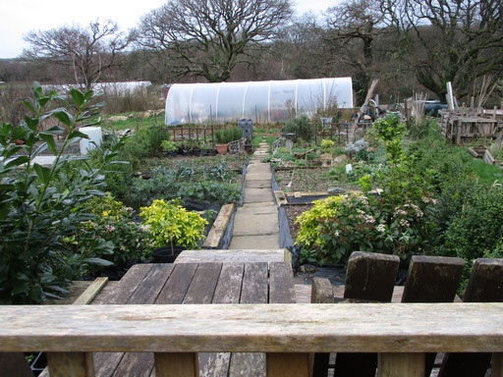
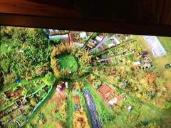 | 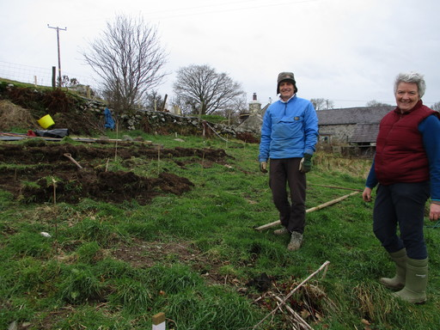 | 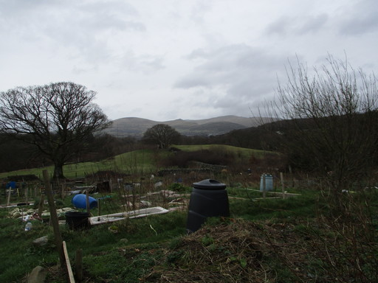

Background information
Ffarm Moelyci was one of the very first community farms in Wales and when it ran into financial difficulties those using it fought hard to find a way to keep it in community ownership rather than being sold into the private sector. The Consortium Ymlaen Moelyci was formed by the various interests involved in the farm including the Allotments, the donkey Sanctuary, the farmhouse, the Nature Reserve, the Woodland and the Composting. These concerns, each now an independent entity, successfully purchased the freehold of the whole farm between them in 2018. The overall ethos is for all these parties to work together for the common good of the community which builds financial resilience into the farm securing it into the future.
There is no council provision of allotments locally and they are sought after in rural areas as well as towns and cities. The 60+ plots at Ffarm Moelyci are on two acres of hillside with spectacular views and were highly valued by the local community - securing their future was important to them.
Start up
The newly formed Tregarth Community Allotments CIC was faced with finding the £12,000 needed to buy just one of the two fields they use for allotments on the farm. They launched a crowdfund which secured a little cash and applied for a lottery grant but were unsuccessful. Finally, the bulk of the money was raised from the plot holders themselves as a series of varying sized loans and the first field was bought in 2018. The other (slightly bigger) field was bought by the Consortium with the rest of the farm and the Allotments CIC have a 5 year lease on this. The loans are being paid off out of the rental income on the plots. When they are debt free they will consider raising money again to purchase the second field on which they hold an option to buy.
During the years of uncertainty about their future the infrastructure of the allotments were somewhat neglected and are in need of some restoration - the group are now in a position to go full steam ahead with this.
The CIC has 6 directors who cover the day to day running of the allotments and form the conduit for the community involvement in decision making.
Activities
There are now 64 occupied plots at Tregarth and there is a waiting list for any that become available. The plots are charged for and this income is what enables the debt for the purchase of the land to be repaid. It is hoped that, once this debt is paid off, the rents could be reduced and in 2019 £3,000 of the £12,000 debt has been paid off.

Their first year as owners has seen good progress and involvement on the site. Much of the rough ground has been controlled and they have installed a caravan as a place out of the weather for a notice board and to make a cuppa. The polytunnel has been relocated and recovered; the space is divided up and all of this is rented out to plot holders.

Tregarth Allotments have taken part in the All Wales Have a Grow Day and open weekends, they have welcomed children from the local school to show them a bit about how to grow veg and have engaged in plant swaps and fundraising fairs. Community days are also arranged – a Balsam Bash to tackle the problems they have with Himalayan balsam along their stretch of river and a Bonfire with BBQ to burn the accumulated wood from the old tunnel.

The future
The aim for the site now is to maintain the momentum and continue a program of improvements and facilities to the site. There is still room to create some more plots but the particular focus is to provide some spaces for people who are less able. The group would also like to engage more with the wider community next year and beyond. There is interest in putting themselves forward for the Green Flag Award.
The group are happy to be on course to pay off the debt to their plot holders and are looking forward to finding a way to purchase the rest of their site.

