Case Study: Cynon Valley Organic Adventures
Abercynon, Rhondda Cynon Taff

Background information:
The Cynon Valley Organic Adventures project began in 2018 on the neglected site of a former large scale growing and wild area.
This beautiful site sits next to the local leisure centre, runs along the edge of the river with a large wet woodland area, an old orchard space, a number of large poly-tunnel frames, allotment style spaces, a large pond and relaxation space – butterfly garden and perennially planted area.
The project began, realising the hidden potential of this space, taking back the space from encroaching bramble and Willow, reclaiming the pond space uncovering the extensive paths and planted areas, managing the Orchard trees and ensuring facilities (shelter/toilets) were installed to enable access.
The project sustains itself through a unique social enterprise model enabling the restoration of this space, wider access to this space for all and fundamentally building relationships & resilience and improved health for those that access the site and the wider community with strong links to local autistic support services, local GP surgeries, Job centre, Communities for Work and community based organisations.
Cynon Valley Organic Adventures at its heart, takes an asset based approach to its work – enabling all individuals to participate and support the wider projects aims.
Group aims:
The group aims to restore and protect this valuable resource for their community and others. In doing so and through their wide range of training schemes, volunteer opportunities and social prescribing build connections between people, health and spending time in nature.
Utilising the space to showcase (through training & volunteer opportunities) to a wide variety of health and wellbeing professionals the impact spending time in natural spaces can have to support individuals in their community.

Main audience and volunteers:
The volunteer team that runs the garden deliver a variety of training courses and workshops throughout the year to provide income to sustain the practical developments and improvements desired in the space. They have accessed a range of funding (Awards for All, Heritage Funding, Lush) for specific developments – outdoor cabin, delivering environmental & wellbeing courses and practical developments.
They work regularly with individuals from their community with a variety of backgrounds and abilities. As is common for community spaces the facilitation of these activities and support for volunteers from the community is currently undertaken by a small core group of organisers.
They deliver sessions and open the space up to all and everyone including – school groups, adult learning groups, summer playgroups, holistic health groups, health care professionals and many more. From conservation and growing activities to meditation and food sharing diversity in their own activities and the range of courses they offer enables a wide range of local and regional groups to access and benefit from this oasis.
What the project is achieving
The project is through a training delivery model enabling the restoration of this space, wider access to this space for all and fundamentally building relationships & resilience and improved health for those that access the site and the wider community.
Its accredited training around Learning and Behaviour Disorders, Families with complex needs and Social Prescribing allows it to be part of a wider program to build more resilient communities with improved health and opportunities through contact with nature.
How group got permission to be on the site/ was it difficult?
The site is currently owned by the charity that formally set up the space. Cynon Valley Organic Adventures have worked closely with the University of Glamorgan business school, the Coalfields Regeneration Trust and Social Farms and Gardens (including CLAS Cymru) to enable them to initially tender to rent the site and as of 2020 towards a position to purchase the land.
The group have faced issues along the way, rebuilding trust with the community – after a promising start (when the land was initially developed) and then neglected by the previous occupiers. The Council (who own adjacent land) then changed the access to the site to pedestrian access only. The group are still trying to gain vehicle access through Rhondda Cynon Taff Council in order to transport essential structures onto the site.
The project maintains a strong relationship with the existing landowners which has been important to ensure that the land remains available for their use and to potentially purchase in the future.
Volunteers Testimony
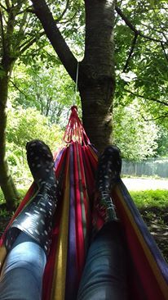
‘This space, in my community gave me purpose at a time in my life when I was unsure where I was heading. It gives us joy to simply be here, to share it with others through the work we are doing.’
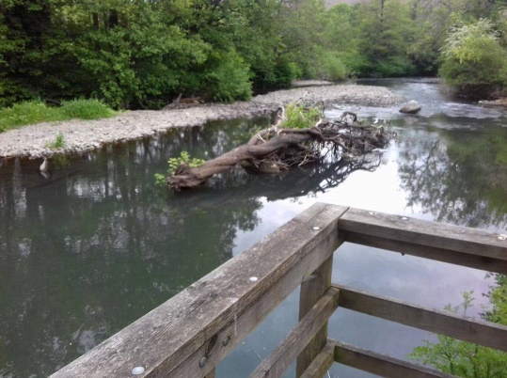
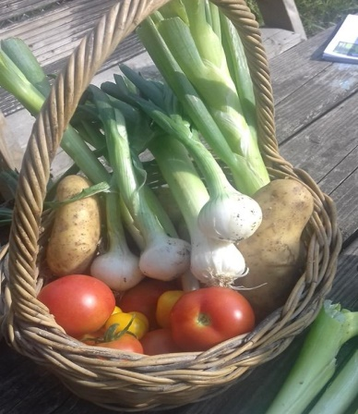
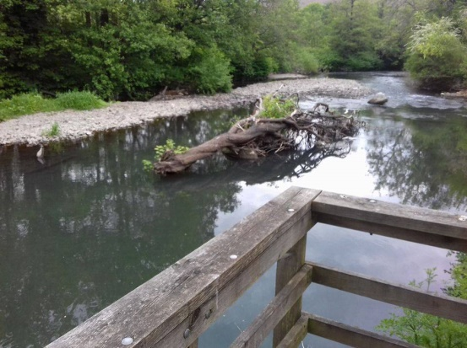
‘The support of CLAS Cymru throughout has been great, guiding us with expertise and allowing us to take a step forward to gaining ownership of this beautiful, important space where hundreds have been able to connect with nature’.

