Mackintosh Community Garden
Roath, Cardiff March 2020

Background information
The Mackintosh Community Garden sits between Plasnewydd, Splott and Roath in a highly urbanised area of East Cardiff. The site forms the corner of land owned by the Mackintosh community Group, the gardens sit alongside a community centre and sports facilities.
Attempts had been made by local volunteers to clear the site which was littered with fly tipping and deep in brambles. A well attended community meeting led to a constituted group being set up, permissions to begin work were gained from the Mackintosh community Group with the help of CLAS along the way.
In year 1 the group secured £2000 from the Neighbourhood Partnerships Scheme to install a polytunnel and accessible paths and a pond. The group have worked over the last 4 years gaining access to small pots of funding and a strong community interest to develop this space in to a thriving, peaceful garden space in the heart of Cardiff. Most recently they have accessed Section 106 money to further develop fully accessible paths, seating and a fire pit area alongside there growing and wild areas.
A beautiful garden and relaxation space has been set up over the last 4 years and has been open almost every Saturday since.
Group aims
The group was set up with the aim of creating a much needed green space. Its ethos and approach to this has always been ‘to welcome everyone and every part of everyone, to enable and facilitate the development of this community space and strength within their own community. To provide a place for people to connect to themselves and their communities.’
Main audience and volunteers
The gardens have worked with a broad range of individuals and families over the last 4 years from over 40 different countries. The area in which it sits hosts quite transient communities, from students to those accessing temporary housing.
At its core the group has a number of individuals and families with young children that regularly come together in the space. The connections built with a range of local organisations and institutions has ensured a rich variety of workshops, placements and activities running throughout the year.
Key relationships with Made in Roath (a local artistic organisation) has seen Cheese making, clay pot making, an artist in residence alongside a range of other events. They have also formed strong relationships with the British and American Delegates Project, The Research Places Institute & the Cardiff Universities (Met & USW) with pHd projects, journalistic projects all adding to the broad range of activities and people that become volunteers in this garden space.

What the project is achieving
Practically the project has managed to transform an overgrown, unused space in to a thriving accessible, open and friendly community asset. The groups ethos and approach to those that come to the space has helped build strong and deep connections within their community, allowing everyone to connect with their senses, heritage and history, encouraging confidence building and a springboard to take that in to the wider world. Everyone is allowed to make mistakes and ‘messy gardening’ is encouraged!
How group got permission to be on the site:
The land this community group were interested in developing is a corner of a larger community space held by the Mackintosh Community Group. The space includes; tennis courts, bowling green and a community centre that hosts a market, meeting spaces and a range of health and wellbeing activities.
The formation of the group came about after a community meeting to discuss the space. The group utilised the expertise of a range of established organisations – CLAS & Keep Wales Tidy – to ensure they had the correct insurance, type of constitution and that the lease they were taking out with the landowner was appropriate. They were able to undertake a 5 year lease on the space as a result.
The Gardens coordinators meet regularly with and maintain good contact with the landowners, the range of public events and overwhelming community support no doubt reinforces that the space is being put to the best of use. The group are confident that they can continue to renew their lease with the land owners.
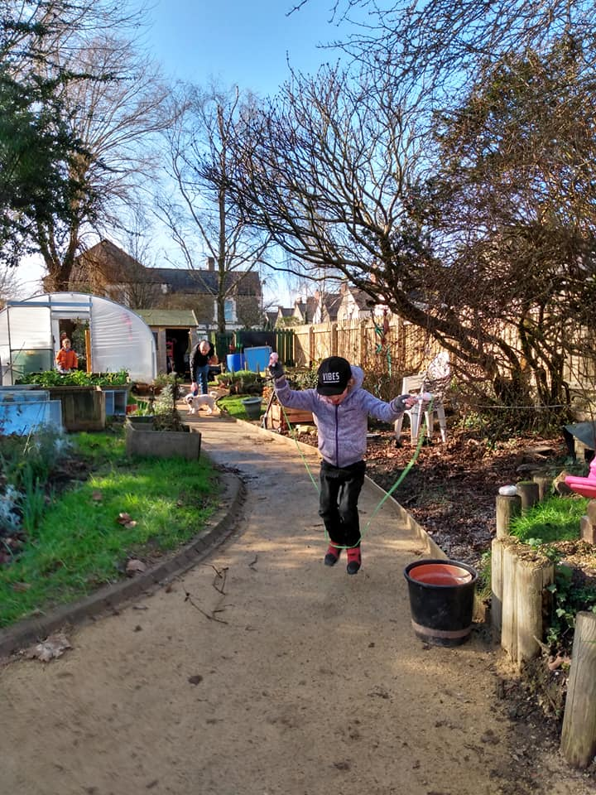
Volunteer Testimony:
The group are hugely grateful to CLAS for their support throughout the setting up of their community project. Helping support their development plans, providing much needed expert advice around their lease, constitution and insurance – that enabled them to take the project forward swiftly and build on the momentum in the community.
‘We love our garden, the connections we make with other people, the land and wildlife.’
‘We have just finished a major bit of work making the garden accessible and we are very proud of what we have achieved over the last 4 years. We want to spend this new growing year filling the garden with colour when we apply for a Green flag award we really want to feel like we’ve earned it.’

