**Case Study: Common Ground –**

**A creative community hub and green space in Cardiff**

**March 2019**

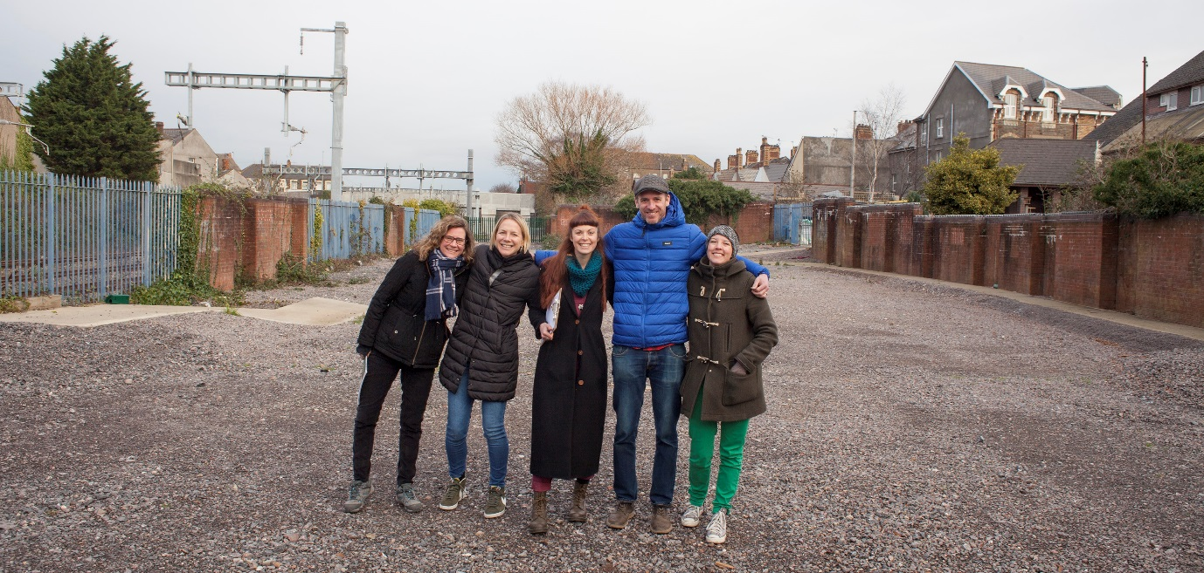

Common Ground is to become a thriving urban oasis where local people can come to learn new skills, connect with their community and access a pocket of green space directly on their doorstep.

Green Squirrel, a local community interest company, was inspired to regenerate a disused patch of land (1,400 m2) to the rear of Railway Street in Splott, Cardiff, owned by Cardiff Council. It will be transformed from a brown field site, providing a thriving community hub and green space for the wards of Splott and Adamsdown, where there is currently an acute shortage of green space.

The project will comprise shipping container studios, a Green City Community Hub, wild play and green space and community-led projects and events. The project will fulfil a need for a good, accessible community space including office space for local start-up businesses; a community hub with kitchen facilities, a classroom space for workshops, and events as well as covered outdoor space, a green space and wild play area containing fruit and nut trees, living willow structures, a greenhouse, perennial plants, muddy play and native plants for wildlife.

**Background**

The Green Squirrel community is made up of local people who want to improve their own lives and build resilient and sustainable communities both across the city and in their local areas. They are brought together by a shared desire to live in positive, sustainable communities, and are composed of many cultures and backgrounds and represent every level of income, education and ability.

The community and stakeholders (in the region of 500 people) include a range of skilled tutors, local social enterprises and business, workshop and event participants, public sector representatives, small charities and organisations, as well as a growing volunteer base.

Volunteers will be at the heart of all events and on-site activities and a steering group (10 people) has been set up whose task it will be to ensure that the space is linked with local people, businesses and groups.



**Getting permission**

The journey to getting permission for this site has been a long one for Green Squirrel and they faced so many barriers, they were ready to give up on their idea until CLAS Cymru stepped in.

CLAS Cymru to could see the huge benefits to the community so suggested Green Squirrel start a campaign to gather public support to show the Council how serious they were and to gain community buy-in for the project. A meeting with the Leader of the Council and Cabinet Member followed and CLAS Cymru have been on hand to support with relevant paperwork and formalities.

Becca from Green City Events said “I really don’t think we would have this piece of land without Lucie from CLAS Cymru – she has been persistent, determined and incredibly professional throughout”

Green Squirrel have obtained permission from Cardiff Council to take on the site and a 20-year lease is being drawn up. Sustainable drainage and planning applications are also being submitted in 2019.