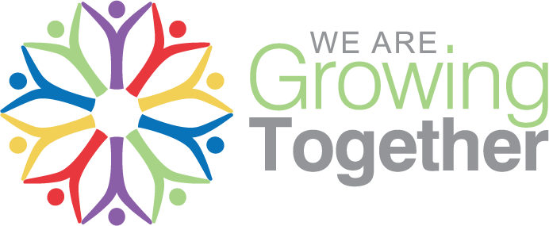
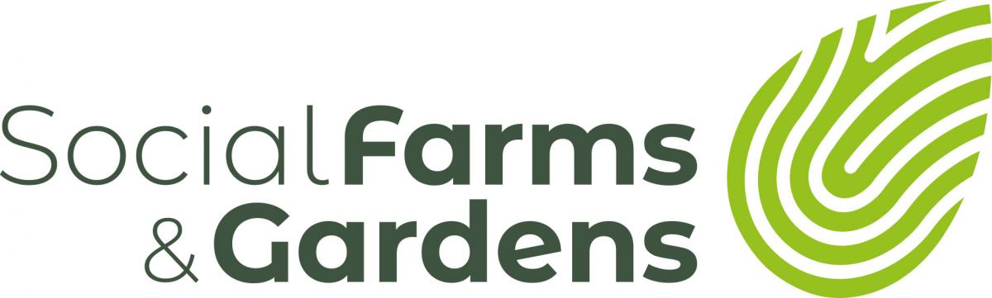

Crowdfunding Questions & Tips

Is Crowdfunding Right For Us?

Though crowdfunding is becoming very popular, it is not right for all projects or groups. Before considering crowdfunding it is worth asking some basic questions.

Will anyone else care about this project?
You may be passionate about a project or a need your group has, but will others? Find out by sharing your ideas with people not directly related to your project, friends, family, other friendly organisations. Ask people who aren’t wary of disagreeing with you! This process will also make you think about how you describe your project.
Does my project fit the crowdfunding model?
One of the key features of a creative crowdfunding campaigns is a tangible goal or “thing.” Another way to think of this question is: how will the world be different once this project is complete? This is what your potential contributors will be pondering. Nobody likes to see their money flow into a black hole, but often that’s what campaigners are doing when they launch with an ambiguous goal. Sometimes, if a campaign starts vague, once you dive into you’ll discover one aspect of the project can be expanded upon to become the more compelling goal.
Is there an existing network of supporters out there?
Who is your community? Not just local people, but can also be those that share similar ideas and values. When considering your crowdfunding project, think: do you have an existing community that can help you spread the word and bring in other contributors with their shared passion?
Have we got a realistic estimated target in mind?
Even before you budget properly, you will have a figure in mind. Is this something you can realistically achieve with the support and capacity your group has?
Are we ready and able to make it work?
Crowdfunding is not a soft option and can often seem like a full-time job during a campaign, so don’t underestimate the amount of work needed for a successful campaign. Some people do it by the seat of their pants and succeed, but many also fail. Think about if you are prepared to go all out to get out there and ask people for funding and really sell the project.

Crowdfunding: Top Dozen Tips

- Summarise your project – make it snappy, easy to understand and memorable. The title of your project should be catchy – eg Edible Fruits & Nuts Growing Project isn’t going to excite – but Fruit ‘n’ Nutty might!

- Work on your key messages – Who, What, Where, How When. These should cover what you plan to do, why people should be excited, who will benefit, how it will make a difference, where it’s happening, when you plan to start/finish. The benefits of the project are particularly important to define.

- Remember, this is an appeal, not a dry funding application. Be accurate, be exciting.

- Think about milestones. Try breaking your project down into stages. What will be achieved if £X amount of money is raised, what would you be able to do if £Y is donated etc. Building this in is for your benefit and for donors – showing you have thought about the project and its impact.

- Decide which fundraising platform to use. Popular platforms include:
www.crowdfunder.co.uk
www.spacehive.org.uk
www.buzzbnk.org
Nesta have a comprehensive list at: www.crowdingin.com/platforms

- Decide on campaign length. 30 days, 45 days, 90 days. The shorter the length, the more intensive the campaign needs to be in order to drum up donations. Longer campaigns allow more time to get donations in, but also potentially mean the campaign begins to drag and lose momentum.

- Budget. It’s absolutely vital to budget properly, to get the right target amount. Don’t forget to include the costs of running the campaign in the first place. Think if there are ways you can reduce project costs – it will make fundraising easier.

- Rewards. Offering staggered rewards are a great incentive for people to take part. Work these out carefully and try to make the rewards unique to your project – that way supporters will feel a sense of ownership and connection.

- Assign Tasks. Like any project, you need to get organised and ensure people have tasks. Look at the skills within your group. People with project management, budgeting and social media skills will be particularly important. Think about who’s going to update the crowdfunding website, who’s going to sort out rewards, who’s going to create posters etc

- Find your crowd. In order to give yourselves the best chance of success you need to think about who your supporters are and how best to reach them. You need to get as many supporters as possible. Buzzbnk’s support pack suggests there are three main groups:
Group 1: Family & friends; people who are close to your organization (staff, volunteers, existing supporters); people and businesses in the local neighbourhood (ie people who might hand out fliers or put a poster in their shop window).
Group 2: People on your mailing list; newsletter recipients; social media followers. The friends and family of these supporters.
Group 3: The rest of the world! People who don’t know about you, but who, through social media and publicity may be willing to support your project (even if they don’t live locally).

- Get your media head on. Crowdfunding is all about creating a buzz and keeping it going, so you will have to exploit every avenue. That means contacting local papers, radio, community media, using social media and websites, contacting other groups and organisations to help, leafleting, postering, speaking at events, using public noticeboards etc.

- Create An Action Plan. Without planning your campaign may not succeed. You need to create profile-raising actions for the whole of your campaign. An action plan will give you structure and help you keep going during the middle of the campaign. Part of the action plan might also be to line up some donations, so you hit the ground running.
Buzzbnk have created a sample Campaign Plan, as part of their Crowdfunding Support Pack as part of the ‘A Team Challenge’, available to download from: http://ateamchallenge.buzzbnk.org

