November 2016 | An Evaluation of  GROWING RESILIENCE: COMMUNITY GARDENS, COMMUNITY RESILIENCE AND SOCIAL CAPITAL  Anna Clarke  On behalf of Federation of City Farms and Community Gardens

Contents
Summary 4
About the Federation of City Farms and Community Gardens 5
Background to the Growing Resilience Project 6
Defining Concepts of Social Capital and Resilience 7
About the Growing Resilience Project 10
Participating Groups 11
Delivery Structure 13
Methodology for evaluation 15
About the Social Capital Baselining Tools 16
Evaluation Findings 16
Bringing people together and increasing community activity 16
Involving more people in a wide range of community activities 19
Increasing Skills and Activity 23
Improving Quality of Life 27
Participant Reflections on the Project 29
Project Challenges 31
Conclusions 32
Suggestions 33

Summary

The Growing Resilience: Community Gardens, Community Resilience and Social Capital (Growing Resilience) project was a pilot project delivered by the Federation of City Farms and Community Gardens during the autumn of 2016. The project was funded by a Big Lottery Awards for All grant.
Four growing groups took part in the pilot project;
- Duneane Allotment Garden, Toome,
- Garvagh Forest School, Garvagh,
- Carntogher Community Allotments/Friends of Drumnaph Community Nature Reserve, near Maghera,
- Incredible Edible, Cloughmills,
All participating groups are located relatively near each other and were identified for their proximity and common focus on growing.
The project involved each group delivering a peer to peer workshop for the other participants aimed at building skills, knowledge and networking capability thus contributing to growing social capital and resilience capacity.
The evaluation of the project confirms it to have been a very positive and beneficial experience for all participants with a strong emphasis on the development of trusting and reciprocal relationships. Replication of the project across other parts of Northern Ireland is recommended.
Some suggestions have been made to enhance organisational delivery of the project.
These include;
- Establishing a set of realistic outcome measures
- Agreeing participation and communication expectations with all groups
- Investing time at the beginning of the project to explore key themes and undertake baselining activities
- Linking the support offer menu to key social capital challenges identified by participating groups
- Encourage each group to incorporate a practical element in their workshops
- Include a dedicated evaluation workshop at the end of each project cluster

About the Federation of City Farms and Community Gardens

FCFCG is a registered charity operating throughout the UK. The Federation has worked in Northern Ireland since 2009 focusing on supporting Councils and other public agencies and NGOs to facilitate grass roots activity and capacity building.
Although only operating in Northern Ireland for a few years, FCFCG is supporting a growing number of thriving community growing groups. The organisation actively works in partnership with other organisations such as NI Environmental Link and Groundwork NI in support of the NI growing movement.

Map of local community growing sites in Northern Ireland.

Activities include:
- Advocacy and support for community managed growing groups
- Promoting community management of green space as a means of empowerment, and to enable the sustainable development of community facilities.
- Supporting the development of community managed gardens, farms, allotments and community orchards throughout Northern Ireland.
- Encouraging sharing and uptake of good practice in community management, via peer-mentoring, events, information resources, networking and site visits.

Background to the Growing Resilience Project

In 2015, FCFCG NI applied to the Big Lottery Fund’s Awards for All Programme, for a grant to run a pilot project with 4 community growing groups. The project was called Growing Resilience: Community Gardens, Community Resilience and Social Capital (the Growing Resilience project). Through its work with growing projects and engagement with members of the NI Community Garden Forums, FCFCG NI identified the need for greater peer-networking and learning between growing groups, to make the most of the developing skills and resources that community groups have acquired. By supporting community groups to engage in this networking activity FCFCG believed that it would lead to increased social capital and community resilience.
The project concept was also informed by three reports published during 2015, which promoted approaches based on collaboration and networking;
- Communities Living Sustainably Learning Report: Growing and Green Space 2015. Produced by Groundwork UK Learning Partnership (FCFCG being one of the five consortium partners),
- Food as a tool for Community Development Report 2015. Produced by Food Matters for Ballymoney Borough Council
- Big Lotter Fund Strategic Framework 2015-21
Having identified the need for a project of this kind, FCFCG undertook further consultation on the project design. This included approximately 40 activists prominent in community gardening groups in NI, officers from all 11 Local Councils, NGO support workers, freelance trainers, managers of projects and on-the ground gardeners. Consultations were held in 2015 at events in Cloughmills and Omagh, to capture the needs of projects in different parts of the country. An on-line survey with potential project participants was also undertaken. As a result, FCFCG made significant adjustments to the proposed model based on consultation feedback.
The final project as proposed in the Awards for All application, focussed on the design and delivery of a pilot scheme working with 4 community garden projects located near each other. The project included;
- working with delivery partners to carry out community visioning and asset audits
- Support to each group to develop at least one marketable asset, with the potential to generate income.
- each group planning and delivering one workshop to members of the other groups, sharing knowledge and skills around the production of marketable assets.
- facilitating networking and support between groups in the delivery of their training.
A key element of the project was evaluation of the social capital and community resilience gains of the project so that FCFCG could then draw on the learning to develop a plan to extend the model across all 11 Local Council areas.

Defining Concepts of Social Capital and Resilience

What is Social Capital
Much has been written about the concept of Social Capital since Robert Putnam’s key publication Bowling Alone: America’s Declining Social Capital in 1995.
The term Social capital is used to describe the existence, pattern and intensity of networks among people and the shared values which arise from those networks. Therefore, the stronger the interactions between people are, the greater the sense of community spirit/neighbourliness/civic participation etc.
The definition used by the Office of National Statistics, (taken from the Office for Economic Co-operation and Development) is 'networks together with shared norms, values and understandings that facilitate co-operation within or among groups'.

How does social capital work?
Strong social networks whether they are formal or informal, foster trust, reciprocity, information sharing, and cooperation, all of which benefit the people involved. Research demonstrates that higher levels of social capital are associated with better health, higher educational achievement, better employment outcomes, and lower crime rates.
Networks are defined as the personal relationships developed when people interact with each other in families, workplaces, neighbourhoods, local associations and other informal and formal meeting places. Different types of networks lead to different types of social capital known as bonding, bridging and linking.

Types of Social Capital
bonding social capital –describes closer connections/ties between people for example, among family members or among members of the same ethnic group etc.;
bridging social capital – describes more distant connections between people and involves more cross-cutting ties, for example, with business associates, acquaintances, friends from backgrounds
linking social capital – describes connections with people in positions of influence and is characterised by hierarchical relations where there are differing levels of power. It is different from bonding and bridging in that it is concerned with relations between people who are not on an equal footing.

Value of social capital
Social capital represents the collective benefit of all the social networks in a community. It is the difference between trying to do things on our own and the added value of accessing the resources available through the social networks we are part of. Social capital is also recognised as having positive benefits for wellbeing through increased trust, family ties, sense of belonging etc. When present, these things contribute to positive health. Healthy relationships contribute significantly to one’s health and wellbeing. Conversely, the health risks from loneliness and isolation have been compared to those associated with cigarette smoking, blood pressure, and obesity.
Research has also demonstrated that infrastructure can have beneficial impact on the development of social networks. For example, common spaces such as community gardens where members of a community can interact and engage around a common purpose can help build and sustain social networks.
The Growing Resilience project is very much about strengthening social networks between growing groups.

Examples of Social Capital

Sharing information & resources | A neighbourhood builds a community garden together using shared tools.
Helping | A church holds a car boot sale to raise money for a local homeless shelter.
Establishing  trust | A group of parents share school pick-up and drop-off runs.

What is Resilience
Throughout history people have been faced with shocks, natural and man-made. Alongside this, people have developed varied responses to cope with, overcome and prevent future impacts. Like others, Bernier and Meinzen-Dick believe that local forms of social capital have a significant role to play in building and strengthening the resilience of individuals and communities enabling more effective coping, adaptive, and transformative capacities.

Bernier and Meinzen-Dick define resilience as;
‘the capacity of an individual, household, community, or system to respond over time to shocks and to proactively reduce the risk of future shocks; these actions contribute to growth and development rather than merely maintain stability.’

Capacities for Resilience
Bernier and Meinzen-Dick have identified three central capacities for resilience: persistence, adaptation and transformation.
- Persistence, or coping capacity, refers to the ability to cope with shocks, and restore well‐being to current levels after the events.
- Adaptation, or adaptive capacities, are preventive actions that people employ to learn from experience or to reduce the impact of predicted shocks. The skills and resources required for adaptation may involve securing additional outside resources or knowledge.
- Transformative capacities refer to the abilities of people to change the larger structures and systems in which they live, implying adaptation at larger scales and thus a more radical shift.
Current thinking argues that a balance of all three are needed to move toward resilience. Clearly, the capacity for resilience within communities is directly impacted by the degree and nature of social capital present. Not surprisingly Bernier and Meinzen-Dick draw parallels between the three types of social capital and the differing capacities for resilience.

Links Between Types of Social Capital and Resilience Capacities

These levels and capacities are not mutually. All three types of social capital may exist within a community. However, the greatest potential for community resilience will exist when the capacity for transformation is present. That is best met through the presence of strong linking social capital.
By examining the social capital structures within a community and seeking to strengthen these it is possible to increase the capacity for resilience within communities and within society.

About the Growing Resilience Project

The Growing Resilience project has 4 core aims directly aligned to the aims of Awards for All. Associated with each aim are a set of indicative outcomes. These are outlined below.

Aim 1 | Outcomes
To bring people together and increase community activity | - Local networks strengthened  - Peer-peer training facilitated  - Distributed networking  - Mutual support between participating groups  - Increased reach of growing groups into wider community
Aim 2 | Outcomes
To involve more people in a wide range of community activities | - Skilled gardeners sharing knowledge  - Skilled gardeners delivering training  - Greater discourse on the needs of community growing sector  - More people aware of local sustainability issues  - Links between people and projects strengthened
Aim 3 | Outcomes
To increase skills and activity | Skills improved will include;  - facilitation skills  - thinking of the project in the context of the wider community  - communicating with other agencies working in the community  - how to plan and deliver a training session in a new subject  - practical skills, increasing their ability to participate in community garden activities
Aim 4 | Outcomes
To improve quality of life | - Groups better able to assess community needs  - Groups better able to meet community needs  - Vulnerable people supported by the group to address personal and social issues.

Participating Groups

Carntogher Community Allotments
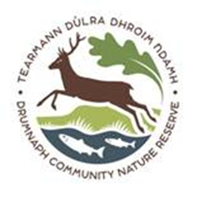 | Carntogher Community Association was formed in 1992 and promotes a range of economic, social, cultural and environmental projects aimed at developing a prosperous and environmentally sustainable rural community.  The Drumnaph Community Nature Reserve is an exciting collaboration between the Woodland Trust and Carntogher Community Association. The land includes  ancient woodland, wildflower meadows, ancient grazing habitats and wetlands.  Carntogher Community Allotments aims to promote healthy living within the local community and offers a wide range of gardening courses and activities throughout the year particularly for beginners or, those wishing to develop existing skills.

Duneane Community Garden
TIDAL is a community group based in Toome, Co Antrim which has been focused on building economic, social and leisure development for over 20 years through provision of services for the local community and employment creation opportunities. The group is based within a purpose built hub, Toome House, which comprises offices, conference rooms and business units.
The Duneane allotment garden project was established in Spring 2016 and comprises 10 community beds, ten personal garden beds, polytunnel, storage shed, chicken coop and space for crafting and cooking. The project has strong intergenerational support with adults, young people and children all engaged. The project has a strong focus on physical and emotional well-being and supports people recovering from anxiety, depression and other mental health problems.

Incredible Edibles, Cloughmills
Cloughmills Community Action Team (CCAT) is a community development group based in the village of Cloughmills in County Antrim working to improve the social, economic and environmental quality of life in the local area.
Through the Incredible Edibles Project CCAT aims to reconnect people with each other, their community and the natural world by developing a sustainable, fair and healthy food system in Cloughmills. The Incredible Edibles project teaches people about gardening, wildlife and growing food. It enables every age group in the village to come together to learn about nature and care for their environment.

Garvagh Forest School
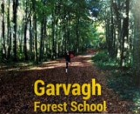 | Garvagh Forest School is one of several innovative and imaginative projects shaping Garvagh Enterprise Trust’s vision for the former Garvagh High School site and adjoining forest, securing use for the community.  First phase of the Garvagh Forest School project was launched in early 2016 with several family and school based activities running since then. This has included 2 forest school programmes in summer and autumn each of 4 weeks’ duration with approximately 90 primary and preschool children taking part. The group has also organised a number of large community gatherings linking forest to town and people to local cultural heritage.

Delivery Structure

The project took place over approximately 5 months from July to November 2016. At the beginning of the project, participants were offered a menu of support that they could access if wished. This included
LONG TERM PLANNING  Establishing the vision of your event  Planning your event: everything from booking rooms to catering to invitees  Recruiting and supporting volunteers to help  Planning publicity/social media  FINANCE AND BUDGETS  Charging for your event  Costing your event | RISK MANAGEMENT  Dietary /other special requirements  Protective Equipment.  Health and Safety, Safeguarding, Risk Assessment, Insurance and other policies  EDUCATIONAL ADVICE  Developing a lesson plan  Delivering your session – building your confidence, ice breakers, time management  How to cater for differing learning styles  Post event evaluation

Project Structure

Each of the 4 four groups planned and delivered a skills share workshop as part of the project. The details of these are outlined below;

Duneane Allotment Garden: The Contemplative and Restorative Nature of Gardening
Event included;
- Display of handmade crafts using recycled and upcycled materials
- Mindfulness PowerPoint by one of the volunteers who is a trained therapist and keen gardener
- Refreshments consisted of bruschetta with toppings from the garden, vegetable soup using the garden produce and lemon drizzle cake, all made by project volunteers.
- Mindfulness and breathing exercise, candlelit walk over to the polytunnel where the group created fairy garden type creations using materials set out and items collected from around the garden by torchlight. Exercise conducted in silence.
- Review of mini/fairy garden creations

Garvagh Forest School: Forest Bathing

Carntogher Community Allotments/Friends of Drumnaph: Our Garden Feast!
Event included;
- Tour of the allotments site/garden
- Meal at An Carn community centre, prepared by the members of the group. This included; sparkling elderflower cordial, fresh breads and oils, a three-course meal using garden produce and more unusual vegetables such as celeriac, homemade apply pie and shortbread biscuits. Homemade gifts for all participants of pots of basil oil.

Incredible Edible Cloughmills: Irish Bread Making
Event included;
- Homemade blackcurrant cordial and mini tartlets on arrival
- Individual demonstrations of how to make wheaten bread, savoury scones, potato cakes
- Small group activity – making soda scones
- Shared meal – homemade soup and fresh breads, tea and coffee
A modest budget was made available to each group to support delivery of their workshop as follows;

£100 room/garden hire,
£150 facilitator costs,
£100 catering, per event,
Total £350 in total for running each event.

Methodology for evaluation

Evaluation was a major feature of the project and was given considerable thought from the beginning of the planning and through the delivery to completion. An evaluator was appointed before the project began and worked with staff from FCFCG from the outset to shape the evaluation process.
A range of methodological approaches were utilised to evaluate the social capital and community resilience gains, including;
- Working with participating groups to map existing networks and connections at different levels before and on completion of the project
- Working with participating groups to audit the skills within their group before and upon completion of the project
- Ensure early engagement with community growing groups new to networking and targeted as part of the project to ascertain;
  - Expectations of the project and networking
  - Incremental benefits as project progresses – how they are benefiting from networking and shared learning and how are they using that learning
- Capture feedback from all participants on each stage of the project
- Capture and share feedback from each delivery group on their experience of planning and delivering their session
- Capture and share feedback from participants from each group on taking part in each workshop
- Capture visually and through social media examples of growing social capital
- Reflections and observations from FCFCG Project Coordinator

Using the Learning
The evaluation process was intended to contribute to learning, not only for those managing delivery, but also for those participating, so the process designed was both formative as well as summative. The feedback from each workshop was collated and shared with all participants in advance of the next scheduled workshop so that each subsequent group could draw on the feedback, suggestions and learning in the planning of their own workshop.
Learning from the evaluation of the pilot project will be used to inform the future development of a NI wide programme.

About the Social Capital Baselining Tools

In addition to the various methods to review and evaluate the project, two specific tools were used to gather baseline date on social capital measures. These were;
- Mapping Community Connections
- Skills Auditing Chart
Each group was encouraged to undertake both baselining activities at the beginning of the project and then to repeat them at the end to determine how the project had positively impacted on the social capital elements. Data gathered is presented in the Findings Section.
An outline of both tools and how they were used is given below.

Connections Mapping Tool
This is a simple way to explore the connections and associations a group has with other groups and agencies. The process is outlined below;
- Write the name of your group in the smallest circle.
- Start to think about who you have connections within the local community – other community groups, schools, churches etc. It may help to think about individual people and then consider who they work for or are what group they are a member of.
- Describe your relationship and links with other growing groups, including those involved in the Growing Resilience project.
- As you identify people, groups and organisations that you have some connection with – consider the nature of the link. Is it regular/positive/beneficial? If so would you describe it as a warm link? If yes, put them on the Warm Links side of the sheet, within the relevant circle.
- If it is a group that you know of but don’t have much dealings with then they are probably a cool link.

Connections Mapping Chart

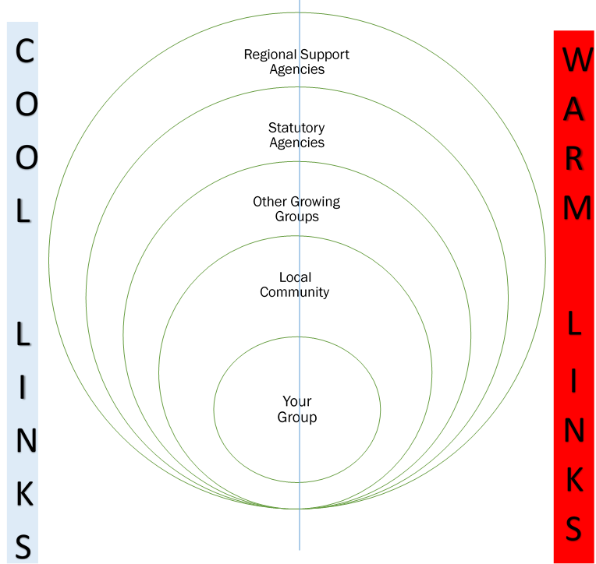

Skills Auditing Chart
This activity is intended to capture some information about the skills within each group that link with the outcomes of the Growing Resilience project.
It is based on the idea of a dart board and each ring has a different score. The centre is the highest score and the outer ring the lowest.

Skills Audit Chart

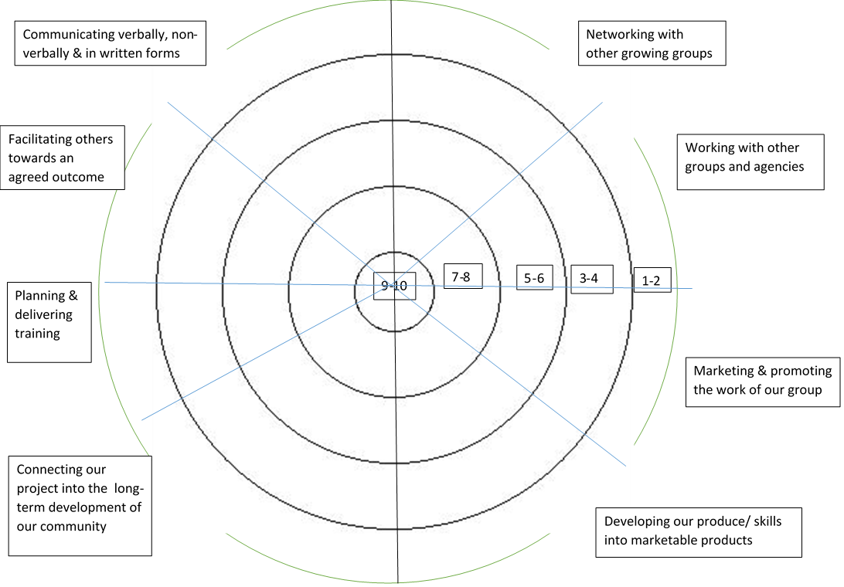

To complete this activity each group needs to follow the process below;
- Take each skills area in turn and discuss with other group members.
- Try and reach agreement on how you would rate your group and then make a mark within the relevant ring and segment.
- Think about your group and what you do in these skills areas that work well and which ones you think you could do better at – that will help you reach a score that you can give.
- You can make notes on the back or on a separate sheet to explain your thinking.

Notes
- The skills box ‘Connecting our project into the long-term development of our community’ is about what you do to link your group/project with what else is happening in your area, how effective you are at generating support from the local community, how your activities complement what other local community groups are doing etc.
- The skills box ‘Communicating verbally, non-verbally & in written forms’ is looking at how well your group communicates in different ways, for example;
  - Verbally – talking to others within the group and outside the group
  - Non-verbally – how you demonstrate intentions – are members of the group welcoming of newcomers? Are you approachable and open to new ideas?
  - Written forms – what methods do you use? How do you use them? Where you put leaflets, flyers etc. How do you use social media?

Evaluation Findings

This section presents the findings from the evaluation process in relation to each of the 4 aims outlined within the Awards for All application. In this section, baseline and project completion data is compared and feedback from project participants analysed to examine the extent to which the project has had impact and contributed to building social capital and community resilience.
Due to the informal nature of this project, delivery has been quite organic in nature and lead to a large extent by participants. For this this reason, several outcomes have been addressed simultaneously and in complex ways through perhaps 1 or 2 actions. However, this is very common with processes that build social capital.

Bringing people together and increasing community activity

From the baseline connections mapping activity, each group has reported positive changes and improved relationships with several organisations. These ranged across the social capital levels as follows:
 | Carntogher Community Allotments | Duneane Community Garden | Garvagh Forest School | Incredible Edibles, Cloughmills
Bonding | Maghera Walled Garden | Toome Women’s Group |  | Cloughmills Vintage Club
Bridging | Duneane Community Garden, Garvagh Forest School, Incredible Edibles, | Carntogher Community Allotments  Garvagh Forest School | Carntogher Community Allotments, Duneane Community Garden, Incredible Edibles, | Duneane Community Garden, Garvagh Forest School
Linking | Federation of City Farms and Community Gardens |  |  | FCFCG, Big Lunch, Big Lottery Fund,  Public Health Agency, PBNI,

Bonding
In the baseline connections mapping all the groups indicated warm relationships with some other groups within their local communities. Additionally, two of the groups reported some positive changes.
- Duneane Community Garden has reported developments in the relationship with Toome Women’s Group with several weeks of contact leading to stronger relationships and friendships. The Women’s Group are now availing of craft resources linked to the garden and joint plans are being made for future activity.
- Incredible Edibles, Cloughmills has reported a strengthening of relationships with the Cloughmills Vintage Club following a Movie Night at the mill.
As part of the Growing Resilience project, a Community Visioning workshop was facilitated. Participant feedback from this workshop indicated that groups feel more confident and aware about how to reach out and engage with others in the community.
‘We intend to hold a community visioning session to help move our allotments project forward.’
‘This will be helpful as we are about to carry out a village plan with Cloughmills Community Action Team/Causeway Coast and Glens Council.’
‘Try to spread word about community allotments. How to advertise more.’
‘To be able to communicate more around our allotment work.’

Bridging
The extent of contact between all the groups participating in the Growing Resilience project has risen significantly.

As a result of connections made during the Growing Resilience project;
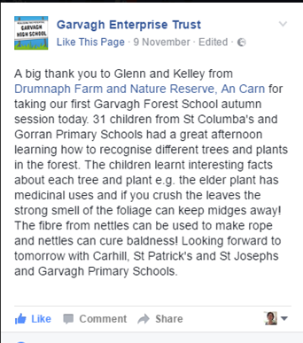
- Members of Carntogher Community Allotments have facilitated outdoor workshops for primary school events at Garvagh Forest School. The group is organising a Christmas Fair and has extended invitations to the other growing groups participating in the Growing Resilience project, indicating growing trust in the relationships. One member has also been invited by Incredible Edibles to run a workshop on fermenting, following conversations at one the project events.

- Incredible Edibles are holding a Christmas celebration and have invited the other Growing Resilience project participants to attend. Several of the groups are also planning to follow up with the Cloughmills group further to get advice on specific matters such as erecting polytunnels. The group have also shared information on different youth award schemes such as the John Muir Award Scheme, an engagement initiative that encourages people to connect with, enjoy, and care for wild places. Members of Incredible Edibles have also visited the Garvagh Forest School (outside scope of this project) to explore different ways of working with young people and toddlers to engage with and experience the forest.
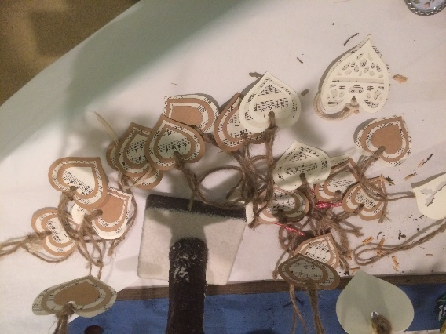
- Duneane Community Garden are now hosting an additional Crafting workshop for members from the other groups in early December. Members also provided advice and guidance to Garvagh Forest School as they prepared for a grant assessment visit from Big Lottery Fund.
- One member from the Garvagh Forest School who has experience of bee keeping is advising Incredible Edibles on the development of their own hive.
These are excellent examples of growing bridging social capital, strengthening ties, relationships, sharing and trust between groups.

Linking
Carntogher Community Allotments has indicated a closer working relationship with FCFCG.
Incredible Edibles has also reported positive changes with several regional and statutory agencies indicating growing social capital at the linking level. Two members of the group now sit on the Advisory Board of FCFCG, the PBNI have visited the project with a view to working collaboratively and the Big Lunch are interested in exploring the use of the mill as a creative hub. Other exploratory discussions are taking place with funders such as PHA and Big Lottery Fund.
However, Incredible Edibles reported a cooling in relations with the PSNI following redeployment of the Community Policing Officer post, resulting in a lack of local liaison.
All the groups described challenges with developing positive relationships and connections (linking social capital) with their local councils. Following the review of public administration and the creation of 11 new ‘super councils’ some of the groups felt more distanced from their council and also expressed frustrations about the inconsistent way in which different growing groups appeared to be treated by their council, some getting a lot of support while others getting very little.
One group observed that while relations had been very poor with their old council, this had changed significantly under the council structure. However, this was viewed with a degree of cynicism as the group felt the change was motivated by how council could benefit, rather than what council could do for the group.

Involving more people in a wide range of community activities

Members of Carntogher Community Allotments, Incredible Edibles and Duneane Community Garden each delivered one workshop/session as part of the Growing Resilience project. Due to unforeseen circumstances, the event planned by Garvagh Forest School has had to be postponed to January 2017.
As a result of planning and delivering their workshops participants all identified growth in their skills and knowledge. The increase in orange columns from 3-5 indicates increased levels of skills and knowledge.

Participants highlighted a range of skills and knowledge areas around which they felt more confident;
Skills | Knowledge
- Bread making skills | - Using vegetables in different ways to eliminate waste
- Balancing/sharing workload | - Preparing a meal for large numbers, multiplying quantities and cooking in bulk
- Presentation skills | - Identifying potential problems and ways to overcome
- ‘letting go’ / letting others take more responsibility | - Learning from experience and applying it to new ideas – fundraising activities.
- How to structure a workshop to ensure good flow | - Recognising the importance of shared experiences, the importance of togetherness and fellowship
- Working together as a team | - Building on existing skills within organisation etc.

Although for many participants this was the first time they had been involved in planning and delivering such events they unanimously expressed confidence in running their event again and in all cases, could identify ways in which they might adapt/improve upon it.
All the participants from all the groups responded that they would now consider running any of the workshops that had been delivered as part of the Growing Resilience project for members of their own group/community, as fundraising events etc. This strongly indicates that they their confidence had increased through participating in workshops as well as through planning and delivering their own.

Participants from all groups found the 3 workshops/events to be highly beneficial. Learning conversations through the evenings covered a range of topics including;
- Therapeutic benefits of ‘green’ mindfulness for adults and children and how to make this accessible through gardening activity
- Using the dark as a way of opening the senses
- Making good use of recycling
- The similarities, differences and challenges that groups face such as;
  - how each group is run
  - difficulties attracting volunteers
  - the importance of prioritising and long term planning
- Different way to use the produce in foods and drinks – for example making elderflower cordial
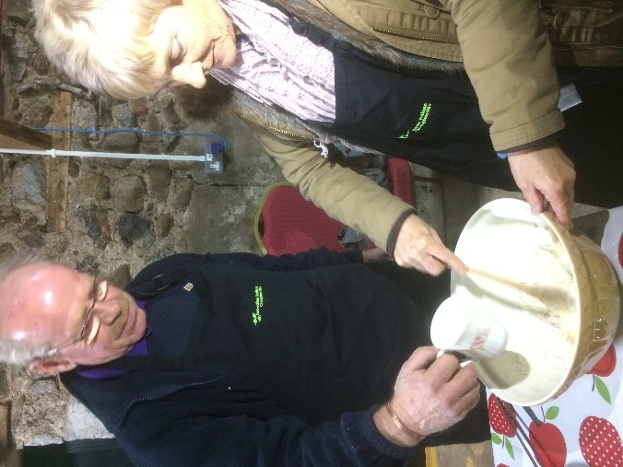
- Bee keeping
- Sharing techniques and recipes on how to make/bake a variety of Irish breads

‘I learnt how to make bread, which I will be making when I go home. I will also be trying it with our group’

‘I learnt how to make three delicious breads but also how simple occasions can bring people together. The recipes are easy to follow and it was nice to have a different person leading each one.’

Each of the three groups that delivered their sessions felt that their events had helped them to strengthen their connections with the other groups taking part, in the following ways;
- enabling them to meet new people
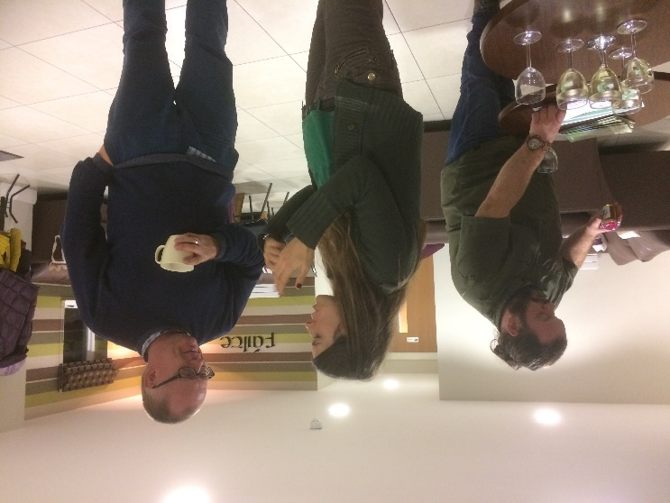
- sharing skills and knowledge
- providing opportunity to chat about their allotments and reflect on what was happening in the garden at this time of year
- exploring together ways to use their events to earn money for their groups
- strengthening of existing bonds and the creation of new friendships
- the shared enjoyment of working with other groups
- encouraging each other to try new things

As participants in each of the workshops they also felt that the events had helped to strengthen connections between each of the groups. Connections and ties were strengthened through;

- visiting each other’s projects/gardens/venues
- involving other group members through the different workshops
- ongoing contact which created the opportunity to get an ‘ever better sense of people’
- building up the confidence of participants
- mutual sharing of information
- creating an environment of shared experience and mutual support ‘we are all in this together’
- Doing new things together

‘As times goes on I am getting to know participants better. It was good meeting other members of TIDAL group I hadn’t seen before.

‘I’ve never been with the garden groups before but enjoyed it so much I will be joining more.’
‘I think the groups are more comfortable in each other’s company. A chance to sit together, work together and chat is a lovely way to make connections. Tonight, I’ve talked about bees, graphic design baking and keeping livestock.’

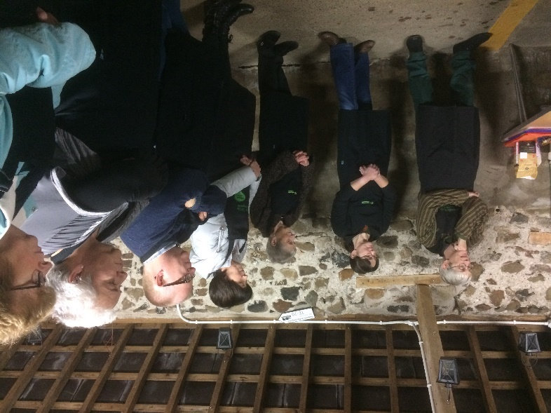
‘Great time to chat. In detail, we talked about chickens, S’s cheap ‘eggloo’! The real therapeutic value of gardening in breaking isolation. Specific requirements of a variety of funders. Food, healthy eating, groups and school visiting. Schools using gardens as part of their ‘Green Flag’ and S petting her chickens with potentially getting raincoats this year!’

‘As this is our third session together, the group members are becoming more cohesive and open. We said we would like to continue to engage with each other.’
Group members have indicated their intention to attend an additional Craft Making workshop being organised by the Duneane Community Garden group, indicating the development of stronger links between groups extending beyond the Growing Resilience project.
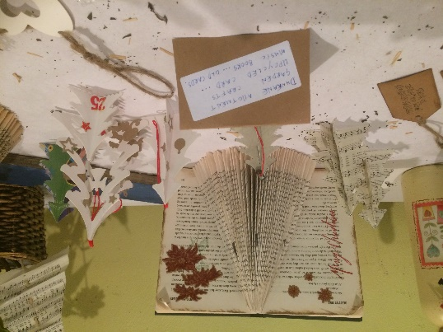
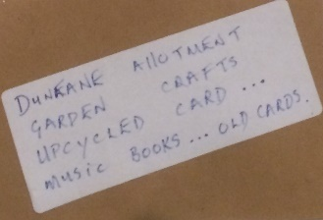

Increasing Skills and Activity

At the start of the Growing Resilience project a workshop was organised to introduce the concept of community visioning. This was facilitated by Community Places. Members of two of the groups took part in this workshop and all felt more informed and confident to undertake community visioning as a result.

Participants felt more skilled and confident in:
- Using more interactive approaches for getting information and obtaining the community’s real opinions
- Using varied methods for consulting – notice boards, ideas boards, planning etc.
- Talking about their allotment project.
- Understanding how the community visioning process works
Participants also felt that the community visioning workshop had helped them to understand how their project fits with the wider community to which they belong. By considering the warm/cool relationships, the connections mapping activity helped participants to visually consider the nature of the relationships their group has with the rest of the community and other groups, organisations and agencies.
‘has made me see there is much more work to do! Our project is one aspect of a much larger project and it is very useful to give this area some attention. (The connections) chart clearly showed where we can improve.’

The Baseline Skills Audit
All the groups completed the baseline skills audit activity. Two groups completed the baseline early in the project and then revisited it at the end. The other two groups undertook the full activity at the end. The results for each of the 4 groups is outlined below;

Duneane Community Garden
The baseline skills audit activity indicates increased skill levels across 7 of the 8 skills areas.

Carntogher Community Allotments
The baseline skills audit activity indicates increased skill levels across 7 of the 8 skills areas.

Incredible Edibles, Cloughmills
The baseline skills audit activity indicates increased skill levels across all 8 skills areas.

Garvagh Forest School
The baseline skills audit activity indicates increased skill levels across 7 of the 8 skills areas. Of interest, here is that this group feels more confident in planning and delivering a workshop even though they had to postpone delivery of their planned workshop. This would suggest that by participating in the other workshops, it helps to build confidence in utilising delivery skills.

Through the process of planning for their events, members of the groups indicated that they met together, and generated different ideas for what they might do.
‘We talked about it as a group and discussed possibilities for the workshop ‘topic’. The group agreed that it would be great to use produce from the garden which is where the idea of cooking a meal came from. We liked the idea of using more unusual vegetables e.g. celeriac, squash etc.’
Roles were delegated, and it is clear from the groups’ self-evaluations that they each drew on existing strengths within their group, as well as using the opportunity to learn new skills within the safe environment of the Growing Resilience project.
‘We used the specific talents that each person had and felt comfortable to use. We had few informal meetings putting ideas in the mix.’

‘We worked on the basis of whatever we liked to do. E.g. S is good at soup so she made the soup and we encouraged her to do some presentation which she has never done before.’

All the groups felt that their promotional and marketing skills had benefited because of the project. Each group produced a promotional flyer for their workshop/event using different computer applications. These are shown below;

Three members of the Carntogher Community Allotments availed of the poster making workshop and produced a flyer for their event. All 3 members rated the workshop 5/5 in terms of usefulness and felt more skilled and confident.

The group has since used these skills to produce a printed menu for their event and flyers for other community garden events that the group are planning. Examples of this promotional work is shown below;
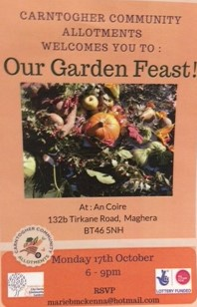

Improving Quality of Life

This is a challenging aim to evidence as it is very wide ranging and long term in nature. The indicative outcomes suggest the starting point is the gathering of clear data on community needs.
The Community Visioning workshop which was delivered early in the Growing Resilience project helped to inform and develop confidence among project participants about the value and benefits of assessing community need and outlined a range of inclusive and participatory approaches that can be used as part of the process.
This report has previously indicated that participants in the community visioning workshop felt more skilled and confident about engaging in the process and found it helpful when thinking about their group within a wider community context.
As a result of the workshop, some groups plan to use a community visioning approach in the future;
‘We intend to hold a community visioning session to help move our allotments project forward. I would also use it for our larger projects.’
‘This will be helpful as we are about to carry out a village plan with Cloughmills Community Action Team/Causeway Coast and Glens Council.’
‘To spread word about community allotments. How to advertise more.’
‘To be able to communicate more around our allotment work.’
Furthermore, feedback from the final evaluation workshop indicated that some members were now giving more thought and consideration to how their growing project linked with their own communities and how the project could better address and meet needs identified.
Revisiting the Connections Mapping activity helped with this as some participants recognised that there was more that could be done/they could do to build stronger relationships (bonding social capital) with other local groups in their own community. Furthermore, they recognised that by doing so it would bring direct benefit to the community including those experiencing marginalisation and disadvantage. While the Growing Resilience project itself did not target ‘vulnerable’ people, the groups shared stories and experiences of how their projects reach out to those most in need – developing projects with children, families, people experiencing mental ill-health, ox-offenders and so on.
The workshop facilitated by Duneane Community Allotment strongly emphasised the therapeutic benefits of gardening and highlighted the positive impact it can bring, for example, to people experiencing poor mental health. These themes were then revisited at each of the other workshops in different ways. For example, the clear physical health benefits of freshly cooked meals made from fresh seasonal produce and fresh breads without numerous additives, preservatives etc., the restorative and rewarding experience of kneading and baking bread and the social benefits of simply eating and talking together.

Participant Reflections on the Project

In addition to considering the success of the project in relation to the stated aims and outcomes, it is also important to consider what participants though of the project overall.

A simple Hopes, Fears and Expectations activity was carried out at the first session and revisited at the end.

Stated Hopes, Fears and Expectations at beginning
Fear of not delivering something worthwhile
Hope to learn new things
Hope to build new connections and strengthen existing ones
Hope to see people not waiting for permission to put up the umbrella
Hope to be part of something bigger
Would hope that this will give each project confidence in their own projects

Reflections

Fear of not delivering something worthwhile
This proved unfounded. Participants felt that all the sessions were worthwhile both in terms of hosting and being hosted. One aspect of this fear was concern that delivery would all be down to one person whereas the team focus encouraged and put into action eliminated this fear.

We had never done all our session in one go – just bits. The support from the other groups made it easier to test it out, a gentle audience. Even after we did it we were chatting about how we could it differently.’

‘We were all in the same boat. Really brought S out of her shell – it was all new for her.’

Clearly the team focus within each group, combined with a small number of participating groups provided a safe environment for individuals and groups to try out new ideas and skills.

Hope to learn new things
While levels of confidence, knowledge and skills varied, participants recognised the tendency to put off trying new ideas and imagining and creating barriers where they don’t exist. The project allowed groups to do these things and see how successful they could be.

‘I learnt so many things …..that I knew could be done but I hadn’t done, to learn it all and even try to bake the bread – I learnt an enormous amount.’

Hope to build new connections and strengthen existing ones
There was unanimous agreement that the project had helped to facilitate this and all participants felt this had brought many tangible gains and benefits.

Hope to see people not waiting for the rain’s permission to put up the umbrella
This term was taken from graffiti on a wall in Derry/Londonderry and quoted by one participant. ‘We don’t need to follow trends/the crowd etc. When we have a good idea, we should do it.’ In general the feedback from participants indicated they now felt more confident to try out ideas they have rather than focussing on the barriers or problems that might arise to the extent that they delay/put off action.

Hope to be part of something bigger
Again, participants confirmed that this hope had been met. Through the connections and relationships fostered and strengthened there is now a sense of being part of something bigger than just own group or own community.

Hope that this will give each project confidence in their own projects
This hope was also considered as achieved. Participants cited examples such as Carntogher Community Allotments going on to organise a Christmas event and inviting the other groups, Duneane hosting a crafting workshop as examples of how the project has raised the confidence and enthusiasm of all the participants.

One participant spoke about the value that taking a team approach to organising their workshop has brought to their group. People now appreciate it is a good way to work and they can work well that way. This means there is less chance of just the same one or two people carrying all the responsibility in future. The team focus has meant they are more flexible and able to adapt and to support each other.

‘If one person forgets something another person is there to pick up.’

One member then introduced the analogy of a triangle to demonstrate this;

Many groups are built like this with one person at the base carrying all the responsibility
With a good team sharing responsibility there is a solid base which will contribute to the group being more sustainable and resilient.

Project Challenges

Overall the structure and organisation of the project worked very well. None the less there were some minor challenges identified;
- Communication with groups. At the start of the project groups expressed a preference for communication through email. The advantages with this is that everyone get the information in the same format at the same time. However, it did prove harder to obtain responses – both for the project and for the evaluation.
- Clarity and understanding of project expectations. Early in the project there did appear to be some variance in understanding around workshop delivery, particularly in relation to input and facilitation. This resulted in one group drawing on the skills of a ‘professional’ associated with the group to deliver the main aspects of the workshop. While the workshop itself was warmly received, this did create some uncertainty for other groups around delivering their own workshops.
- Low take up of additional support offered through the project. Although a wide range of support was offered, it appears that only the community visioning and the poster making was accessed. As take up was optional this isn’t a big problem, but if development support is to be offered with the intention of bringing added benefit it is important to ensure that what is offered is relevant, timely and accessible to maximise take up.
- Attendance. In general, this was very good. All groups were represented at all the group workshops but some early events were not so well attended. However, numbers varied from group to group. While it is impossible to avoid absence completely, it is beneficial for the overall cohesion of the project to set a minimum number of participants per group and establish the importance of attendance as part of the focus on building strong connections.

Conclusions

Overall the Growing Resilience project has been highly successful and beneficial in terms of building social capital and resilience.
By bringing together a small cluster/network of growing groups to engage in the project, strong relationships have formed, characterised by sharing, trust and reciprocity. There was a high degree of independent distributed networking reported among groups and a strong wiliness and desire to share knowledge and skills. This has and will continue to contribute to a strong self-help ethic which will build independence, resilience and sustainability.
The experience of engaging with the community visioning and connections mapping aspects of the project has also facilitated groups to explore the nature and quality of relationships with other groups, organisations and agencies and identify ways in which they can positively develop these, particularly at bonding and bridging levels.
Through the connections mapping process groups have identified some challenges with the quality of relationships with statutory agencies, particularly local councils (linking social capital). However, within the structure of the project there was little opportunity to explore and address this.
Three out of the four groups have successfully planned and delivered their workshops. All workshops were well received with significant learning reported alongside the growing relationships. It is interesting to note that the fourth group has committed to delivering their workshop beyond the timescale of the project indicating a high level of engagement and association with the project and other groups.
All groups and project participants have indicated significant skills development through the project, which have been achieved through a variety of means – i.e. input facilitated by project organisers and the peer to peer learning through the group workshops and visits. Groups indicated greater confidence in all the specific skills area targeted by the project.
For some participants, the Growing Resilience project took them out of their comfort zones. It is a measure of the success of the project, and the level of peer support within and across the groups that participants have risen to these personal challenges and overcome the fears and concerns they had. And having done so, are now actively amending, improving and planning to do more, whether it is to repeat their own workshop or a new one informed by those delivered by the other groups. This has resulted in an increase in the number of people within each group taking on new roles, sharing their skills and talents, utilising new skills and engaging with the wider community.
In addition to the specific skills associated with their own workshop themes/topics, each group has further developed transferable skills associated with team working, marketing and promotion, communication and presentation skills.
Through the project, participants have explored and shared ideas about the ways in which growing projects can help to improve quality of life, particularly in relation to physical health and mental well-being. This increased awareness has enabled participants to think more specifically about their own groups and how to target and focus activities where they are needed most within their own communities.
Organisationally, some minor challenges have been identified primarily in relation to communication, attendance and time commitments. These have not impacted the project’s overall success but are worth highlighting as part of the pilot.

Suggestions

- Roll out the Growing Resilience project. Given the level of success of the Growing Resilience pilot project, and the benefits gained by the participating groups, the project definitely merits replication on a wider scale so that more growing groups can take part and benefit.
- Review outcomes for each aim and establish a set of realistic outcome measures for each aim that are achievable within the timescale of the project.
- Establish and outline clear expectations in relation to participation in the project. Consider a simple contract which is outlined during recruitment stage and agreed at the Introductory workshop. This is less about holding groups to account and more about seeking to ensure maximum benefit for all participants through informed and consistent participation. Consider setting a minimum number of participants for each group to ensure engagement with all aspects of the project.

- Include 1 full day workshop at beginning of each cluster project at which participants;
  - are introduced to the aims and outcomes of the project, concepts of social capital and resilience,
  - undertake the baselining activities
  - consider these elements clearly in relation to their own groups and communities.
This will help to ensure a strong connection between the project and the social capital and resilience elements.
- Use feedback from Introductory workshop to inform the support offer menu. For example, if during this process some groups identify poor linking relationships with Councils then this would illustrate a key area for support from the project organisers through the project.
- Agree a protocol for communication which could include;
  - Provision of email addresses for at least 2-3 members each group
  - Agree key contact for each group and
  - seek agreement to respond to emails within a set timeframe

- Encourage each group to include a practical element in their workshops as this is something all participants valued.
- Include an evaluation workshop at the end of each project cluster with at least 2 hours dedicated to review activity. This will be a more effective way of gathering post completion data and evaluation feedback rather than combining with a meal.

Putnam, R. D. 1995. “Bowling Alone: America’s Declining Social Capital.” Journal of Democracy 6:65–78
Foxton F. and Jones R 2011 ‘Social Capital Indicators Review’ Office of National Statistics
Bernier, Q. and Meinzen-Dick, R. 2014 ‘Resilience and Social Capital’ CONFERENCE PAPER 4 Building Resilience for Food and Nutrition Security 2020
Due to unforeseen circumstances this workshop had to be postponed and rescheduled to January 2017.

