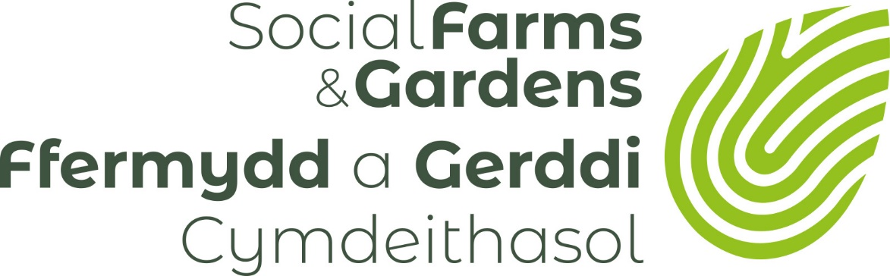

Finding Land for your community green space project: Start Here
Introduction
The Community Land Advisory Service (CLAS) is a programme managed by Social Farms and Gardens and is here to help communities find and manage land for all types of community green space projects; including community gardens, wildlife areas, therapeutic gardens, orchards, woodlands, bowling greens, community supported agriculture projects, care farms, play spaces, memorial gardens and playing fields. The basic steps you need to take to start your search for appropriate land are very similar and the information here will help clear the path for you to see your next steps.
Starting the Process
Before you start looking for land you need to have some idea of what type of community project you want. Does the space need to be within walking distance of the community managing it? What is it to be used for? Does this mean that certain priorities have to be met (i.e. within 500 metres? south facing land? access safe for children? Locked at certain times of the day? etc). Discuss this with your community group to get a broad shopping list of your needs. There are helpful tips on starting this process in the Social Farms and Gardens Resource Packs www.farmgarden.org.uk/resources. It is useful to have a broad shopping list of your needs but when speaking to landowners and public bodies you may need to be flexible to what land they have available. In this sense, it is good to prioritise your needs.
Fill out the ‘Introducing Your Community Led Project’ form available on this link
This form will provide important initial information to a landowner/ local authority with a view to acquiring some land for a community led project or enterprise. It will also be very helpful to the Community Land Advisory Service staff who will be supporting you to acquire the land and gain all the necessary permissions. It is best to try to complete the form as best you can as early as you can. You can present it to potential landowners, and you can also re visit the form to complete more parts of it as you move forward with your project or enterprise. It will help you write your business or management plan and is also the type of information potential funders like to see.

Identifying Suitable Land
Using your general ‘shopping list’ start a thorough search of land in the area you have identified as suiting your community’s needs. Be flexible and wide ranging at this point. Try to avoid being too restrictive. A piece of land which appears to be inappropriate now, may end up being your preferred option.
Similarly, a piece of land which looks the best at first glance could have some problem which you will not be able to overcome without significant time or cost resource.
Consider land at your local school, park, health centre. Are there road verges you could plant or a smaller woodland or hedgerow you could look to manage or improve in order to prove your worth?
If no land seems to fit your needs, can you change your type of project to meet the potential sources of land available? Will this still meet your community needs or will you have to agree changes with your community group?

Spreading Your Search
If you do not have a particular site in mind – or are not developing an existing piece of land – there are plenty of useful information sources. Use internet mapping tools and satellite images to look for vacant, green or underused sites, talk to local people, local businesses local contacts, the library and your community centre. Talk to your local school, church and council. Finally use social media and nextdoor.com to ask questions about vacant land in your area.
Speak to a Community Land Advisor
We have CLAS Advisors in some parts of the UK who are able to advise you on the next steps for finding land for your projects. Please contact us at our head office to find out more by emailing admin@farmgarden.org.uk or use this page for more contact information https://www.farmgarden.org.uk/about-us/contact-us
Contact your Local Authority
All local authorities have bits of land that is not being used for the time being, has been underused for some time or is surplus to requirements. Finding the right person to speak to in a local authority can be tricky. It is always advisable to speak to your local ward member first as they can advise you who you need to speak to and can be very helpful to the progress of your project. Depending on where you live our CLAS Advisors can help you find the right people to speak to. Social Farms & Gardens can put you in touch with a similar project who manages some local authority land. Some local authorities have community asset transfer officers or departments, so it may be helpful to search community asset transfer on your council website to see if they have set procedures to follow and how to contact them.
Negotiating with the owner, consulting neighbours, mediating with stakeholders?
Local authorities and public bodies have set procedures for transferring even the smallest of spaces for community management. They will often want to see that your group is constituted, has terms of reference, insurance and is able to write a business or management plan for submission to them. Social Farms & Gardens has advisors that can help you with this depending on which part of the UK you are located. There are also other agencies such as the Wales Council for Voluntary Action in Wales or NAVCA in England or SCVO in Scotland.

Permissions and Consents
You will need to think about the following:
- Getting planning permission or other consents to use or build on the land. If you want to build structures, look for a site within the settlement boundary of an area, rather than in the countryside.
- You may need a lease agreement with the landowner but sometimes a licence will be adequate.
- You may want to buy the land.
- Whether there are any specific controls on the land, such as listed buildings or whether the plot is in a Site of Specific Scientific Interest.
Always contact your local authority about the constraints, covenants and planning conditions on a particular site before entering into any legal agreement to take the site on.
Do you need other support?
If your community group needs support and advice for other matters relating to starting a community green space project, for example getting established, finding funding, developing a business plan or to design the site, then the best place to start is by contacting Social Farms & Gardens.

