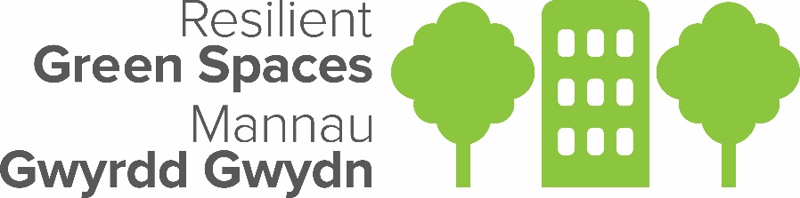

Ymylon Gwyllt Ymylon Gwell

Contact Form

Key contact information:

Main Contact Name
Email Address
Phone number
What community group, organisation or community council do you represent?

Does your group already have Public Liability and Employers Liability insurance (also covers volunteers) to cover your activities?

In what village or town is the verge or greenspace you’d like to manage? Please use https://what3words.com/ to pinpoint the exact location of the verge or greenspace or a Google pin.

If it’s a verge, would a member of your group be willing to attend a free training session on signage and safety for works adjacent to the public highway?

Please indicate which of the following support would be useful to you (tick all boxes that apply):
Tools and equipment
Insurance advice
Permission from landowner
Community consultation
Risk assessment advice
Wildflower survey workshop
Management plan
Community group support and development

Please tell us anything else that might be useful about your group and the verge/greenspace:

If you have any questions about this form, you can get in touch with the Ymylon Gwyllt Ymylon Gwell Team by contacting Sarah Collick at Sarah@farmgarden.org.uk

Resilient Green Spaces is a £1.27m partnership project being led by Social Farms & Gardens to pilot alternative re-localised food systems using communities and their green spaces as the driving force for change across Wales until June 2023. This project is funded through the Welsh Government Rural Communities - Rural Development Programme 2014-2020, which is funded by the Welsh Government and the European Union.
