Case Study: The Historic Hafod Walled Garden
The Hafod Estate, Pontrhydygroes, Ceredigion March 2019

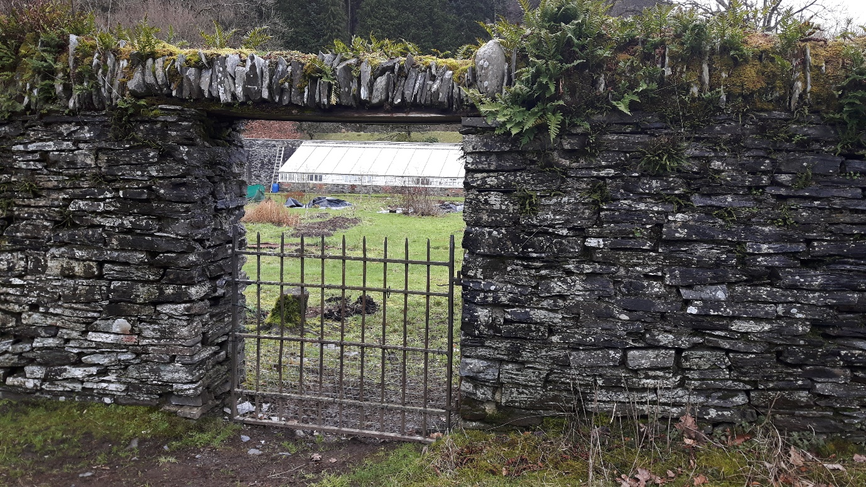
The Hafod Walled Garden Group first met informally in October 2018 and currently has 12 members who all share a commitment to environmentally friendly gardening and to increasing local biodiversity.
‘I’ve lived on the Hafod Estate since 2006 and have obviously made some good friends but I think this beautiful Walled Garden might be the right space to make some real local connections and give our little local community more of a collective voice. And I want to learn more about gardening!’
(Ned, group Volunteer)
Early maps show that the Walled Garden beside the river Ystwyth on the rural Hafod Estate has been cultivated for at least 200 years. The high stone walls contain 2 acres of flat land, remnants of box hedges, two large Victorian glasshouses and a substantial stone outbuilding. Much of the site had not been cultivated in recent years until the group took it on.
The Walled Garden is now being brought back into full use as a community growing project having gained initial permission from the owner of the Hafod Estate. The Community Land Advisory Service helped draft a suitable licence in consultation with the landowner and testing has been done to establish that the presence of heavy metals in the soil and water run-off is within safe parameters. Social Farms & Gardens have advised on food plants (including apple trees) unaffected by traces of these and recommended use of raised beds containing clean soil for certain vegetables.

Further activity plans have been drawn up with plans for income to be generated from produce for sale, from a skills training programme and the continuation of the native-species tree nursery.
The landowner has recently carried out some maintenance on the glasshouses and re-roofed the outbuilding. When the tree nursery licence came up for renewal, he welcomed plans to develop further gardening activity with involvement from the local community. Much progress was made and within the first 3 months a draft lease agreement was ready for final review by both parties.
‘[The landowner] was impressed at our horticultural knowledge and wish to involve others living on or near the Hafod Estate. I think this gave him confidence in the project and he’s already offered to contribute the irrigation system we’ll need.’
(Malcolm, group Volunteer)

