Case Study:
Friends of Llanfrechfa Grange Walled Garden
Cwmbran, Torfaen March 2019

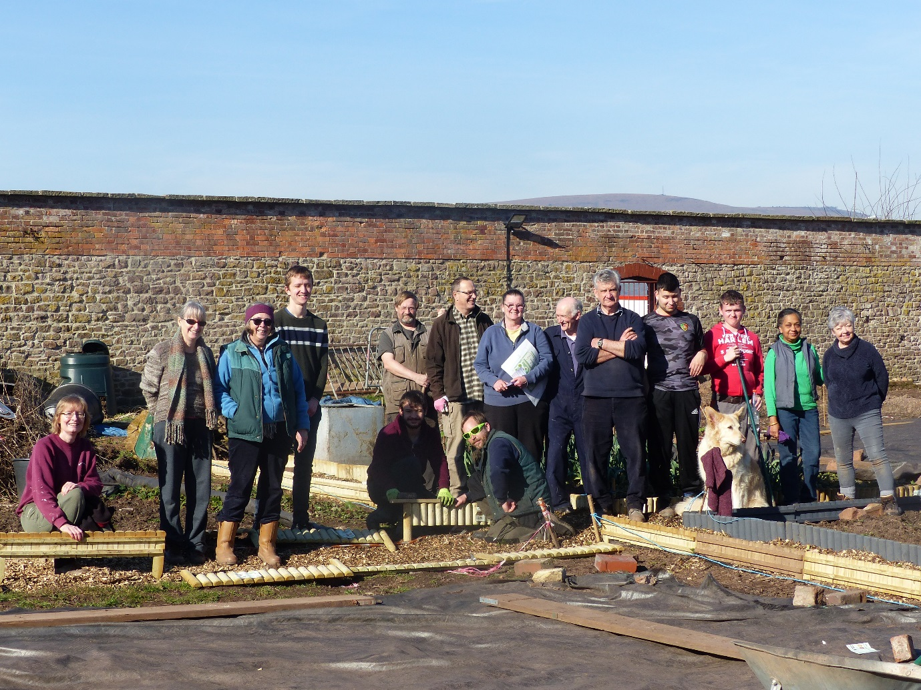
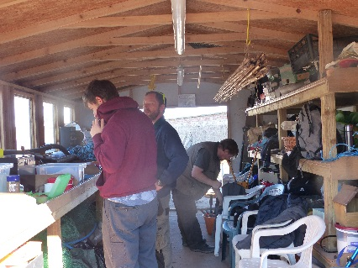 |  | 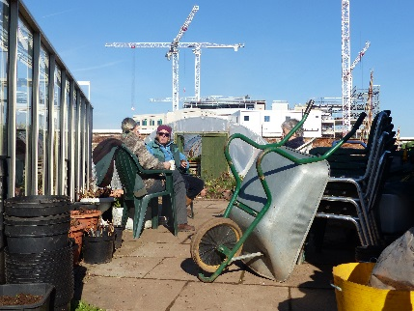

Background information
This community walled garden project is in the grounds of Llanfrechfa Grange Hospital near Cwmbran. The whole site was originally a privately-owned manor house. Built in the mid-1800s, the garden would have provided the Victorian household with fruit, vegetables and flowers. It became a residential hospital for people with learning disabilities in the 1950s, with some of the residents regularly working in the garden as part of their daily activities.
The Walled Garden was boarded up in the 1990s and was derelict and completely overgrown when the Friends first entered it in 2014. Once their planting and restoration work is finished the garden will provide a physical link between the old manor house and the new specialist and critical care hospital being built on the site. The new hospital, which will be known as the Grange University Hospital, will be a regional critical care hospital and is due to receive its first patients during the spring of 2021. The Friends of Llanfrechfa Grange Walled Garden aim to have the garden laid out and fully planted to coincide with the opening of the new hospital.
Start up
In 2013, some of the staff at Aneurin Bevan University Health Board asked the Health Board if they would consider allowing it to become a community garden. This idea was well received, an initial steering group was set up and the Friends Group was formally established in December 2015. There are currently around 20 regular volunteers and more who come along for less frequent ‘working group’ days.
They have a formal arrangement to manage the land through a licence from the Health Board to operate within the garden and they are currently negotiating a long term lease with the assistance of CLAS Cymru. They have also been offered help securing legal advice through Law Works.
Jan Smith MBE, chair of the charity, said “CLAS has provided us with support, information and advice. Always responsive to requests for help their advisors are very knowledgeable and their enthusiasm for community land management is infectious. We look forward to a continuing relationship with them.”.
The Charity was set up in 2017. Its aims are to create and maintain an uplifting multipurpose garden for the benefit of patients, staff and the public who use the new Grange University Hospital, and for the wider community in the hospital’s catchment area.

Activities
Currently the group has a dedicated Garden Design Team who meet regularly to develop a detailed landscape plan for the garden and a Garden Team who have established a regular working day of the week where they work with volunteers who undertake tasks ranging from digging, planting, weeding to building paths and other features.

The Group has a philosophy of re-using materials wherever possible eg stones, paving slabs and hard core. Much of this has come from the building works at the hospital site but some materials have come from nearby buildings that have been decommissioned.

The aim is for everyone to be able to enjoy the garden. This is likely to include people living locally and those who work at the hospital. It will also be a peaceful and reflective place for visitors to the hospital who have friends and relatives undergoing critical care.
At present the garden is not open to the public but anyone who is able to work independently in the garden is a welcome volunteer. All sessions are supervised by one of the Trustees.
In addition, they provide sessions for people not able to work independently, as part of a horticultural therapy programme with ‘Growing Space’ a local mental health charity. This is currently limited to young adults with autism spectrum disorder, but in the future, they hope to extend this to accommodate other groups.
The future
The final plan for the garden has now been adopted by the group. The work being carried out is on schedule for it to be completed and formally opened to the public at the same time as the new hospital opening in spring 2021.
It is expected that the volunteers who have worked so hard to build the garden will continue to maintain it and the garden will become an oasis within the grounds of the hospital that will provide a place to reflect for patients, a place to relax for staff, and food for both people and wildlife.

