Case Study: Monks Wood, Sustainable Wick Community Group
Wick, Vale of Glamorgan

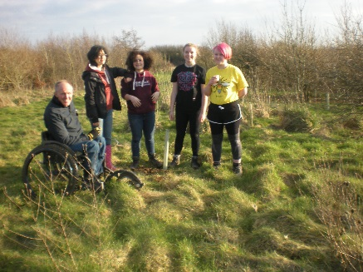 | 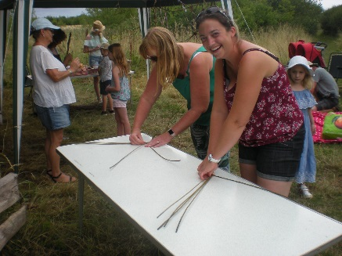 | 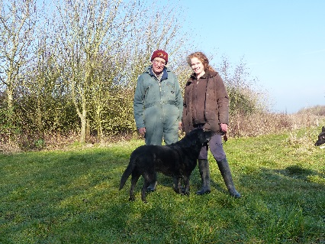
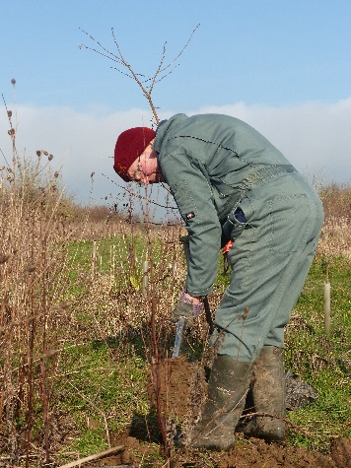 | 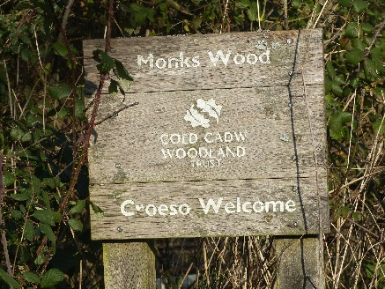 | 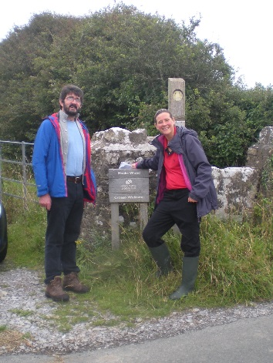
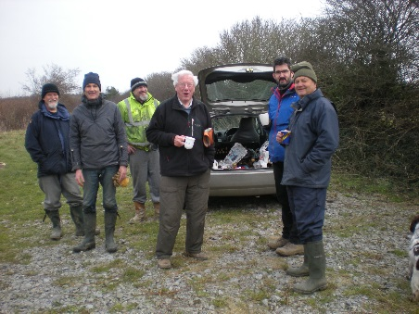 | 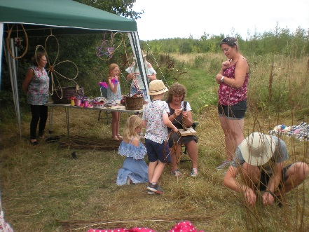 | 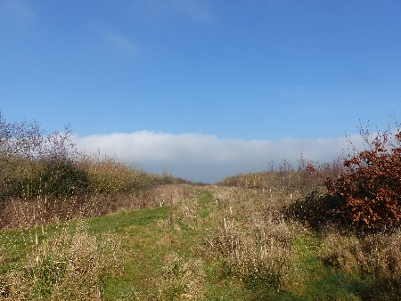

Background
Monks Wood is one of The Woodland Trust's 'Woods on Your Doorstep' woodlands, created to commemorate the Millennium. The 4.2ha site, close to the coast, is managed by Sustainable Wick Community Group (SWCG). The name Monks Wood was suggested by the children of Wick and Marcross Church in Wales Primary School in recognition of the monks who were associated with the land in medieval times.
Previously, the site had been farmland since it was enclosed and in its recent cropping history has been grassland, then arable crops were grown until 1998. Now, the vast majority of the site is native broadleaf trees, of which 5,714 were planted in 1999/2000 and over the years various new trees have been added to increase biodiversity, including 2,000 planted in 2012 to replace those lost in a horse grazing incident and to introduce more pioneer species.
There are a number of trees present, ash, field maple, rowan, willow sweet chestnut, aspen, bird cherry, alders, downy birth, whitebeam, wych elm, and willow added by the group and a few conifers and wild cherry planted by local people.
The site was originally managed by the Woodland Trust supported by a committee of volunteers called Monks Wood Committee who were all local people. In 2012 Sustainable Wick Group was set up following a Permaculture Design Course which prompted the group to do something to promote sustainable living in the local community.
Group aims and how many members
The objective of the group is to promote Sustainable Living in the local and wider community by organising community projects and community events. There are 41 individual members plus Atlantic College Environment Department and Wick Youth Club. Recent events have included working days at Monks Wood, a Community Twmpath, an annual Apple Festival, meetings, talks, willow weaving course, green woodworking, scything and tree planting days.
The group work with nature and recognise that they are part of a web of life. They wish to maintain and enhance biodiversity, use sustainable resources and management techniques and develop small local solutions.
They hold regular volunteer days at Monks Wood including tree care, management of community willow bed, community forest garden maintenance, condition surveys. These events are open to anyone who wishes to attend.
They are slowly building relationships within the local community and in turn with nature, and through activities they are raising the profile of the Monks Wood so that it will feel like it is owned by the whole community.
Support from CLAS Cymru
CLAS were instrumental in negotiating the lease from the Woodland Trust. The process started at a tree planting and forest garden activity day on site where a WT Ambassador said they ought to think about leasing the whole wood. This process took 3.5 years which included allaying fears of members and setting up a limited company.
Mike, the Group’s Chairperson said “without CLAS we wouldn’t have had the lease, they enabled us to do this and saved us a lot of money on the way on things like solicitor’s fees”.

