Volunteer Coordinator Job Profile

We are a small non profit organisation based in Stobhill, Northumberland and run various community initiatives throughout our region. We are looking for a forward thinking Volunteer Coordinator to join our small team of friendly staff and volunteers. Our projects address social and economic issues faced by disadvantaged people throughout South East Northumberland tackling issues such as; health and wellbeing, food poverty, social isolation, disability, low attainment, unemployment, digital exclusion plus many more social and economical factors. Our work is grant funded and we operate at a grass roots level.

We are looking for someone to join the team who has the following skills and abilities:

You will need to be confident to coordinate and manage a large group of volunteers for a dynamic and busy organisation. You will need to be able to proactively recruit and induct volunteers, manage relationships between volunteers and staff and also work productively with other organisations. You will need to be able to motivate and inspire. You must possess excellent organisational skills and ability to communicate with people from diverse backgrounds and experience.In addition this you will need to maintain organisational policies and procedures, and promote the organisation and its volunteer accomplishments. Your goal is to ensure that NCEL recruits and supports a diverse range of appropriately skilled, reliable and committed volunteers to help them fulfil their mission whilst brining opportunity to local people looking to contribute towards a good cause and up-skill in order to realize their full potential.

Essential
- Knowledge of safeguarding vulnerable people
- Good understanding of the voluntary sector
- Full, clean EU/UK Driving license
- Good communication skills
- People skills with the ability to coordinate and motivate others
- Ability to develop learner portfolios
- Strong knowledge of Health and Safety systems and quality controls
- Good plant and growing knowledge
- IT skills
- Excellent speaking, writing and presentation skills
- Team-working skills and the ability to develop contacts in organisations
- Administrative and organisational skills
- good maths skills for budgeting

Registered Office: Northumberland Community Enterprise Ltd, 37 Shields Road, Stobhill, Morpeth, Northumberland, NE612SA

01670519575 enquiries@ncenterprise.org.uk www.ncenterprise.org.uk

® Company No: 6537591 ® Charity No: 1174831

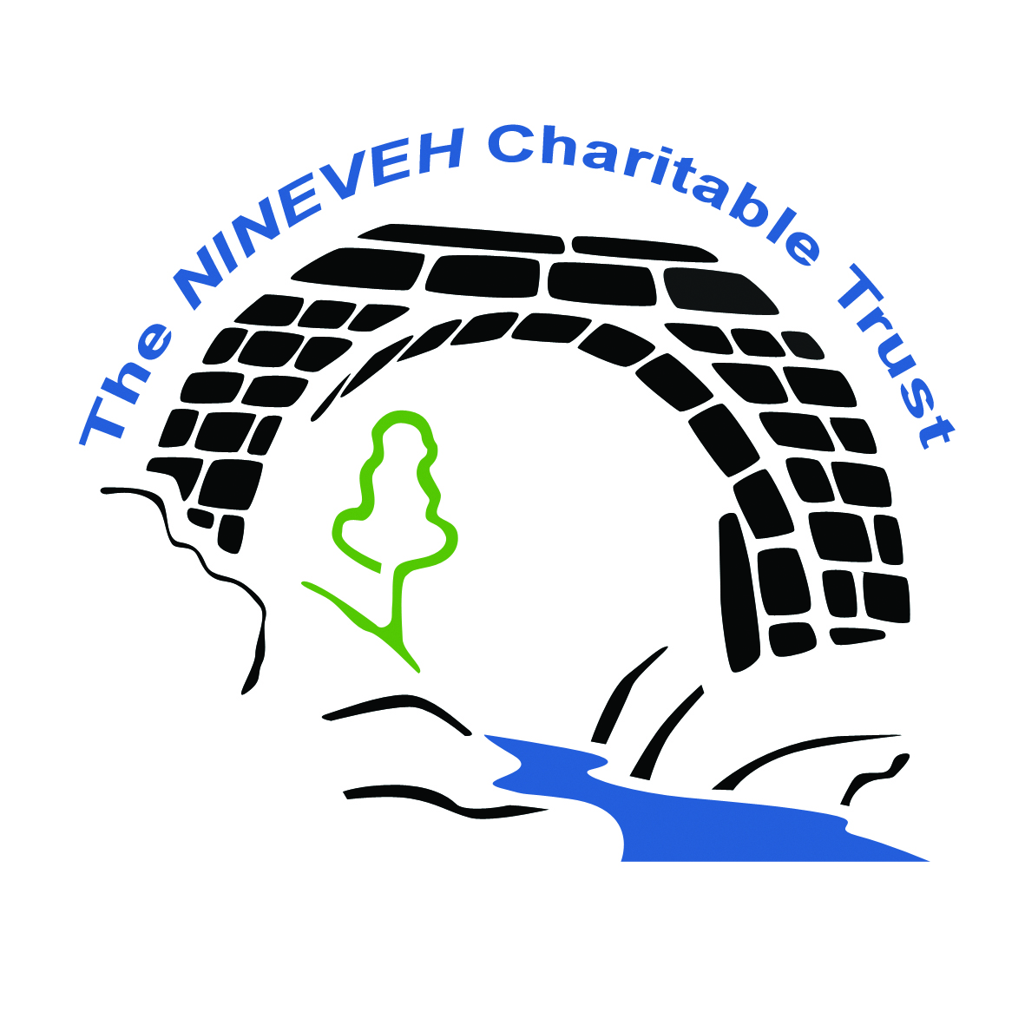

Desirable
- First Aid Certificate (This can be provided/updated)
- Safeguarding Training (This can be provided/updated)
- Training Workshop Delivery experience
- Teaching qualification and subject experience/knowledge
A successful candidate must be willing to have an enhanced DBS check carried out.
What you will do

- Designing recruitment activities to attract volunteers
- Interviewing volunteers and conducting inductions and risk assessments
- Matching people to vacancies
- Arranging or delivering training
- Giving ongoing coaching and support
- Working with other agencies
- Keeping records up to date, including databases

Salary and Benefits
We offer a great benefits package such as 30 days holiday plus statutory holiday, a pension scheme and an office location with easy access to the A1 and Morpeth.
Salary: £8.20 per hour for 16 hours over 3 week days.
If you would like to apply for the position, please email a covering letter on why you think this role is for you and attach a copy of your CV to nceljobs@outlook.com

