Case Study: Open Newtown –
Unlocking a great green community resource
Newtown and district/Powys
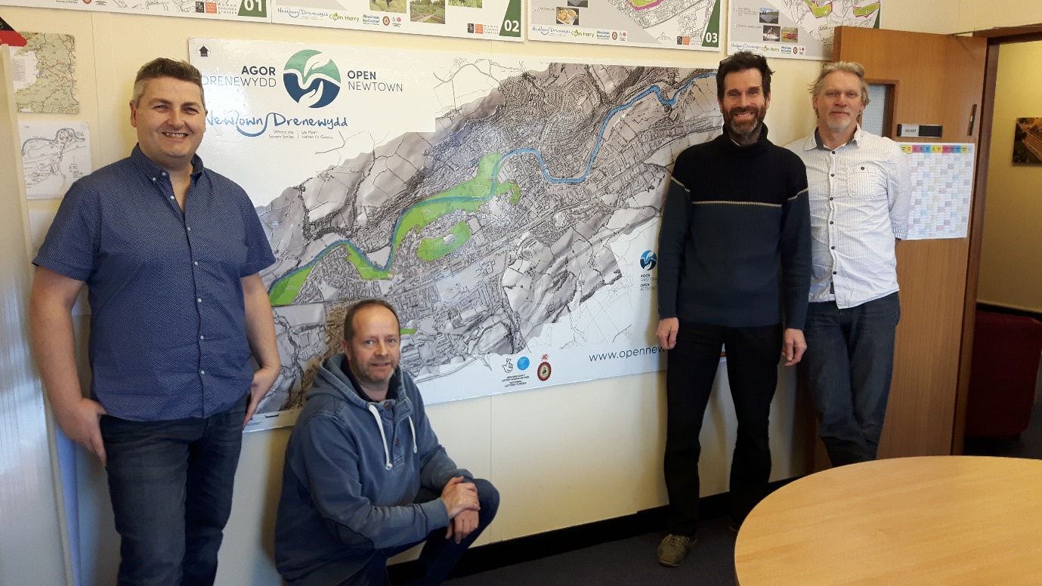
Stuart, Gary, Jeremy and Adam of the Open Newtown team, February 2019. The green highlights on the Newtown map show some of the green spaces included in this large project.
Background
Newtown, the largest town in Powys, has a number of open spaces formerly managed by the County Council’s Countryside Services division, including a wonderful green corridor alongside the Severn as it flows through the town centre. In 2013 Powys County Council, reviewing a grazier’s tenancy agreement of one of these, began to consider passing this and other land into community management as a cost-saving measure. At the same time a community-led consultation identified green spaces, environment and energy and getting around as top priorities for a local Action Plan. Newtown & Llanllwchaiarn Town Council, becoming more active in delivering local services, and existing community food-growers joined the discussions and the Cwm Harry Land Trust led a Newtown bid to the Big Lottery Community Asset Transfer Fund. This resulted in an award of £1.1m with a contribution of match funding from Newtown & Llanllwchaiarn Town Council and a target for income generation to meet within a 5-year business plan. Most of the County Council owned green spaces are included in a 99-year Lease agreement; the largest such transfer in Powys. A further holding under Welsh Government ownership is being transferred Freehold.
‘Green spaces like this deserve more than just having someone to cut the grass. We want the green spaces to be used. We want the green spaces to be loved. Newtown is central in Wales and has excellent transport links to neighbouring regions. The green spaces can become focal points and form links within the town itself.’ (Gary Mitchell, Director, Open Newtown)
The Group and its aims
A new Community Land Trust called ‘Going Green for a Living’ was set up to take the project forward with agreed partners. Under the name of ‘Open Newtown’ its key objectives are to involve the local people in enhancing the biodiversity of the spaces, enabling new enterprise and creating more opportunities for activities, events, food production, energy, health and wellbeing for residents and visitors to the area. This will involve some improvements of infrastructure as well as sympathetic landscape management. It is a big project involving the recruitment of a small steering team of skilled local people into contracted employment.
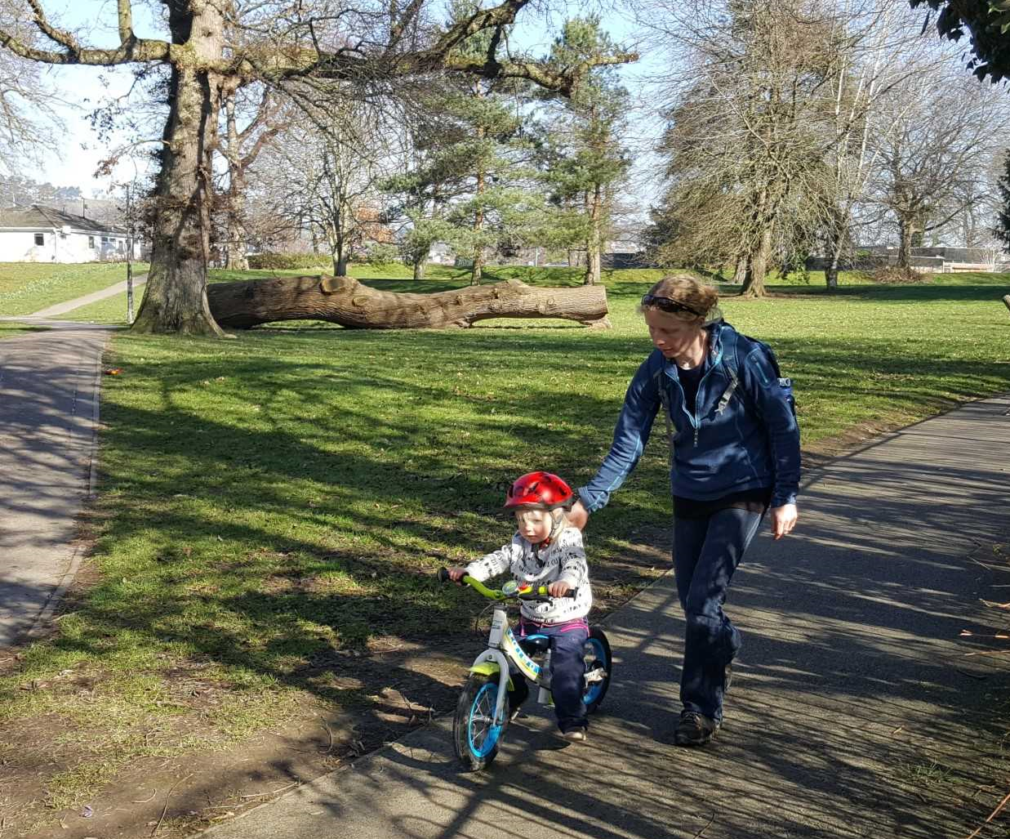
The large Dolerw Park in the town centre has a magnificent river frontage
Main audience and volunteers
Open Newtown’s Community Liaison officer will encourage wide collaboration and participation amongst local residents and businesses, and with groups active in and around the town with special interests in wildlife and river habitat, local food-growing, sports and outdoor recreation, local business and tourism, renewable energy, events and festivals.

What the project is achieving
Open Newtown is becoming increasingly recognised as a very significant economic driving force for mid Wales: an ambitious project that will meet many agreed needs and serve a wide range of local interests in an around the town. The land transfer and associated negotiations, the funding applications, partnership working arrangements and business planning – some ongoing - have been on an unprecedented scale. The next phases of the project will have greater public appeal and more opportunities for direct community participation. It is an exciting time for Newtown!
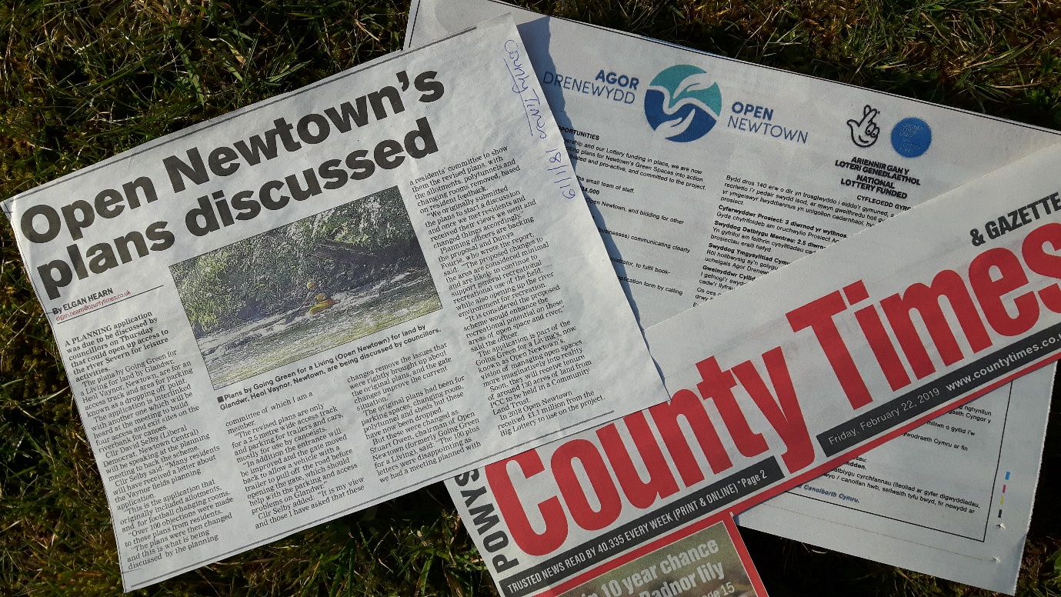
There is extensive media coverage of the project and its successes to date in the Welsh press and social media
Obtaining permission to be on the site
‘When negotiating with a Local Authority, be aware of the cycle of Local Government elections. Our negotiations were very protracted not just because quite a lot of land was involved, but because we were suddenly dealing with a new set of County Councillors with different views on some issues.’ (Newtown & Llanllwchaiarn Town Councillor & Mayor, Sue Newham)
Group members’ comments about their experience to date
‘I like the diversity of the project and its great potential to stimulate and promote the town. I spent my formative years in Newtown and then came back to settle here, so I think I can count myself a loyal Newtonian!’ (Gary Mitchell, Director, Open Newtown)
‘It’s a good idea for community groups to get the direct support of a Town or Community Council. There are always some costs associated with managing a public green space and these Councils have the power to raise a precept to fund these. I’d also advise getting legal advice - available free to many community groups in Wales through Community Land Advisory Service Cymru - to ensure that there’s nothing in a Lease to cause problems in the future for either party.’
(Cllr Sue Newham)

What they hope to achieve in the future and their aspirations for a Green Flag Community Award
Applying for Green Flag status would not only highlight Open Newtown’s commitment to managing safe and attractive spaces for people and wildlife, but also emphasise the project’s close and essential relationship with the community who live and work in the town and its catchment.

February 2019

