Case Study:
Outside Lives Ltd
Maeshafn, Mold, Flintshire February 2020

“Our mission is to facilitate stronger, healthier community connections through the celebration and protection of our natural world.”
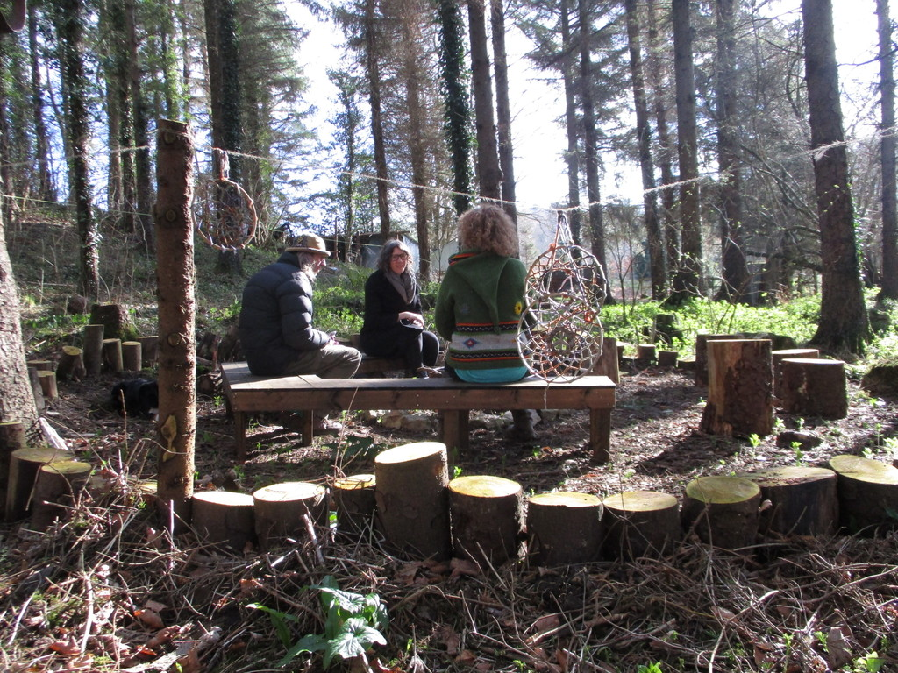
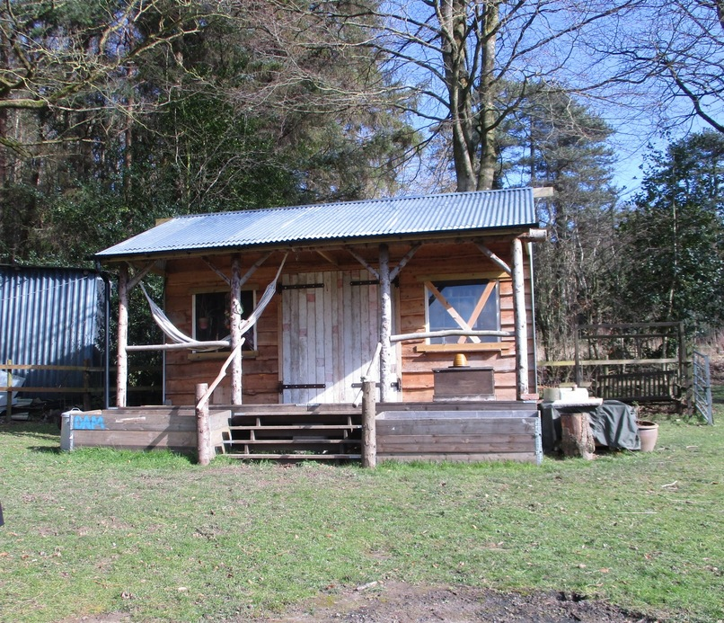 | 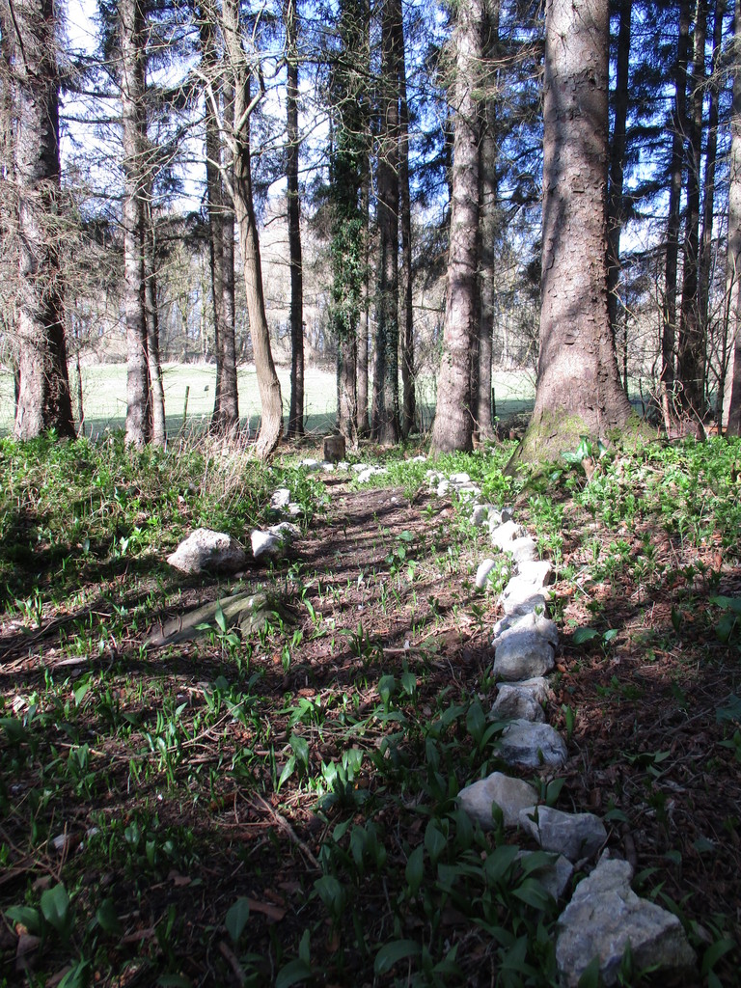 | 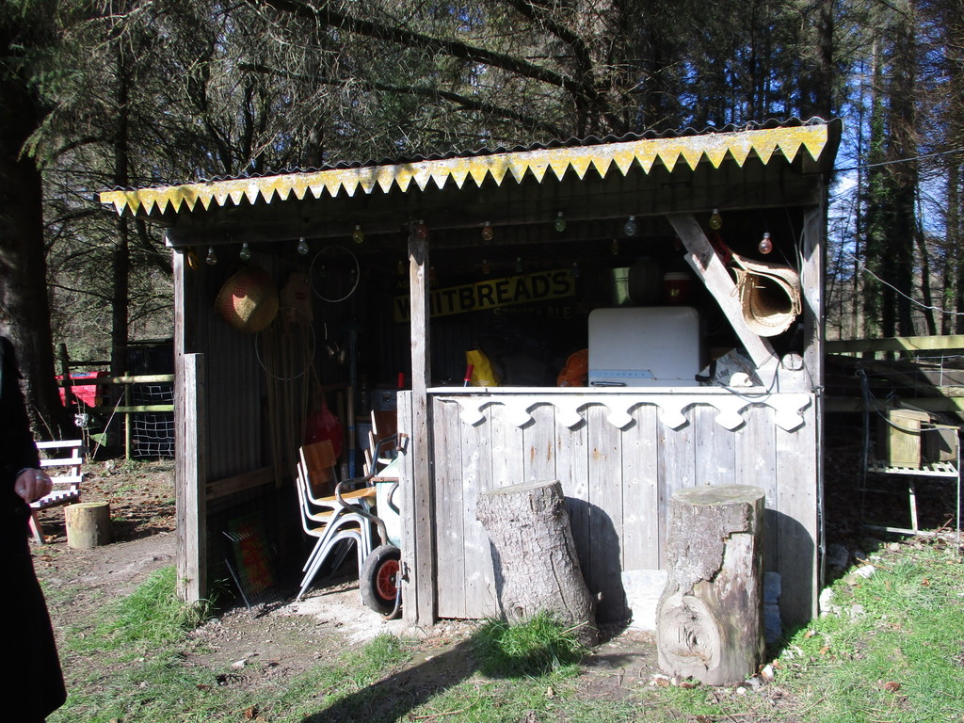
Background information
This newly formed social enterprise is based in the grounds of Aberduna Hall, a family home on the borders of Flintshire and Denbighshire in North Wales. Its founder, Lucy Powell, had honed her vision over a period of years for a vehicle to provide a wide range of socially inclusive activities, largely based around nature and the environment. She finally left her job as a social worker to implement this vision in Outside Lives Ltd. Its purpose is to ensure that people of varying abilities and needs can fully participate by offering an accessible and safe space for the whole community to pursue interests and enjoy activities together.
The idea for its concept was inspired by permaculture philosophies and these guide its interactions not only with the land but also with people.
The land extends to four acres and encompasses woodland, field, orchard and garden with a cabin, compost loo and a fire pit.
Start up
Outside Lives Ltd was started in 2019 by Lucy Powell. Her experience in social work coupled with her interest in permaculture coalesced into an idea for providing opportunities for different sectors of her community to interact and enjoy activities together. Having permission to use the land at Aberduna Hall, enabled her to build the project around that and the company has just secured a ten year lease. The structure of the enterprise is built around a number of groups each dedicated to a different aspect or activity. These groups are largely led by volunteers who have coalesced around Lucy’s powerful concept of how the community should be interacting with each other.
Activities
Outside Lives Ltd has attracted volunteers to form nine groups. These operate both on the OL land and at other venues around the locality.

Briefly, the groups are: The Wild Tribe (Environment and conservation); Dig In ( Community gardening and veg growing); No Plan(et) B (reducing impact on the natural world and carbon footprint); Foodies (shared meals, cooking skills); Adventures (all ability abseiling, climbing, canoeing); Take Note (music); Art Box (creativity); Green room (Theatre and drama); Mind and Body (outdoor yoga, mindfulness). All of the groups focus on being accessible to all regardless of ability or circumstance.

As the wide range of groups implies the activities offered are very varied. Recent examples are The Wild Tribe who organised a treasure hunt for local children - the ‘treasure’ being special finds on the Outside Lives land at Aberduna - followed by a trip to a residential home for the children to share their treasures and elicit reminiscence. The newly launched Dig In Group is a monthly veg growing workshop with a local grower. The group will learn about planting within the permaculture way in the newly formed forest garden area. Produce grown will be used by the Foodie group to demonstrate cooking skills and share a meal.

The future
Outside Lives is keen to improve the accessibility for wheelchairs to allow as much access as possible to the whole site. They would like a small café/kitchen for providing soups made from the produce in the garden and are also consulting with RENEW about their options to go off grid.
Creating The Enchanted Wood area is a project for this year along with developing the forest garden where a selection of new fruit trees is ready to be planted around. Managing the sizeable area of woodland will be an ongoing task as will improving all the on site facilities. All these tasks will provide multiple opportunities for the volunteers to enjoy working together and develop new skills.
All development will be firmly within the principles of permaculture. As a new enterprise their aspirations are for all the groups to become self sustaining and to create a legacy of inclusive community relationships.
Outside Lives is working towards achieving their Green Flag Award.

