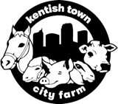

Risk Management Planning Notes DRAFT 18.5.20

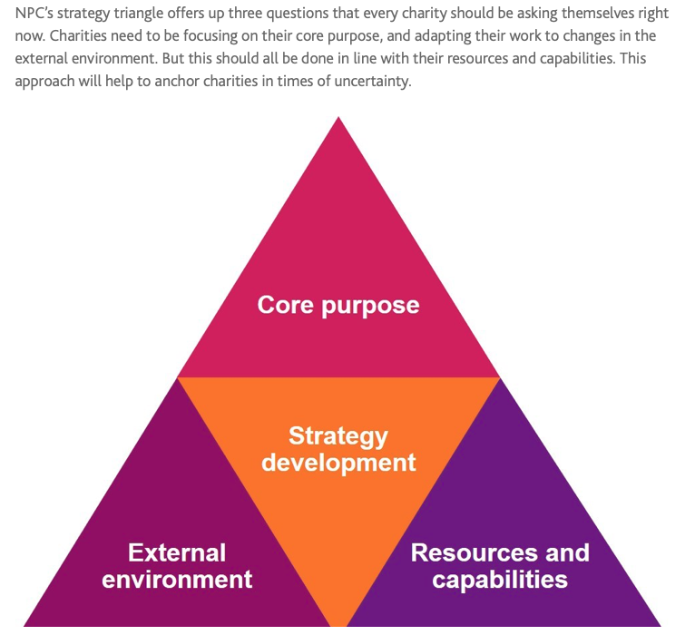

New Philanthropy Capital, Apr 2020
Aim
The aim of these notes is to collate information from a small number of influential sector organisations* about managing risk and planning for the short and medium term.

Your picture of the Farm’s circumstances will be more accurate and comprehensive than mine but I hope that at least some of this research adds a little certainty to the process of planning during uncertainty.

Summary
Boards should:
- adopt a streamlined and flexible decision making process, making use of evidence-based advice and guidance
- follow the updated Covid Charity Commission trustee guidance [p.3]
- plan from the charitable objects and consider adapting core purpose and mission if necessary [p.3]
- review how operations deliver the charitable objects [p.4]
- create short and medium term scenario plans [p.5]
- update the SWOT analysis weekly [p.6] including a competitor analysis [p.8]
- be aware of funders’ perspectives [p.7]
- employment recovery advice [p8]
Appendix: charitable objects in full

Useful sources*
What charities must do:
Charity Commission
Practical advice and resources (all now free to access) to ensure best practice is followed
National Council for Voluntary Organisations
New Philanthropy Capital (innovative, evidence-based, influences funders and government policy, resources for planning & training)
Funders’ groups & perspectives
London Funders (represents high profile funders (inc L.A.s & corporates) to London and national policy makers, e-bulletins inc funding, stats, emerging initiatives/trends)
Institute of Fundraising (advice, guidance, training about all types of fundraising strategy, regulation, best practice)
Competitor analysis: Social Farms and Gardens
Free daily email updates about all things charity from civilsociety.org.uk
1. Charity Commission updated guidance
The Charity Commission’s Covid Guidance offers comprehensive advice for Boards to ensure legal compliance and what needs to be considered in a variety of circumstances.
https://www.gov.uk/guidance/coronavirus-covid-19-guidance-for-the-charity-sector

2. KTCF Current vision/mission statements

Vision: To exemplify the power of City Farms to improve the lives of urban people by caring for animals and the land together.

Mission: To improve the mental, physical and social well-being of everyone in our area of benefit (Camden & London) with a focus on educating young people about the environment & farm life

Values and focus:

Inclusive: we value the whole community, reduce disadvantage and grow a sense of belonging through civic participation

Ethical and excellent: we deliver on budget to a high quality and make evidence-based decisions.

Fair and respectful: we treat everyone and the natural world with respect.

Personal growth: we enable people to learn, achieve, create, develop and thrive.

3. Charitable objects delivery.

Covid response plan key: moved online; Note: The charitable objects are summaries – full text is in the Appendix.

1.To promote the benefits of connecting with nature and each other to local and London-wide residents. | 2.To improve the life chances and personal development of local and London based young people and others through learning about animals and the environment. | 3.To educate local and London-based young people in humane animal welfare.
Festivals & Community Activities Programme
1.1 Outreach events inc Lon Harvest Festlval | 2.1/3.1 Young Farmers Club
1.2 Room hire | 2.2/3.3 Playschemes: Easter, Sum
1.3 Community justice reparations project | 2.3/3.3 Equine Programme (Pony Club)
1.4 Welcome desk [from Spring 2020] | 2.4 Gardening prog: Under Fives | 3.4 Schools, inc specialist schools
1.5 Festivals: May, Oct, Dec | 2.5 Gardening: Community Gdn | Education: Thurs & Sat Learn with Chris
1.6 Yoga | COVID RESPONSE Fri: story time
1.7 Weekend pony and donkey rides
1.8 Volunteering (could be considered core)
1.9 Wellbeing gardening groups
1.10 Corporate volunteering
1.11 Visitor centre : Sunday live & daily SM
4.To provide learning or training opportunities for London residents experiencing disadvantage to enable them to become economically active. | 5.To improve the quality of life of people experiencing health and wellbeing disadvantages through a range of leisure activities including horse and pony riding. | 6. Core activities which support the objects.
4.1 Duke of Edinburgh Award Scheme | 5.1 supported volunteering | 6.1 capital projects
4.2 Work placements | 5.2 Sunday Social Club 60+ [from Mar 20] | 6.2 site safety, maintenance, animal welfare
 | 5.3 Riding for people with disabilities | 6.3 staff, volunteer, comms, finance mngt
 | COVID RESPONSE: staff keep in touch with existing service users via regular phone calls | 6.4 Accountability: Governance, Risk mngt, membership, AGM, Annual Report,
 |  | 6.5 Fundraising
 |  | 6.6 Stewardship, donor management, M&E
6.7 Growing network & commty connections
COVID RESPONSE: Lon F&G Planning Mtgs

Programmes and projects interlink and may deliver more than one charitable object.
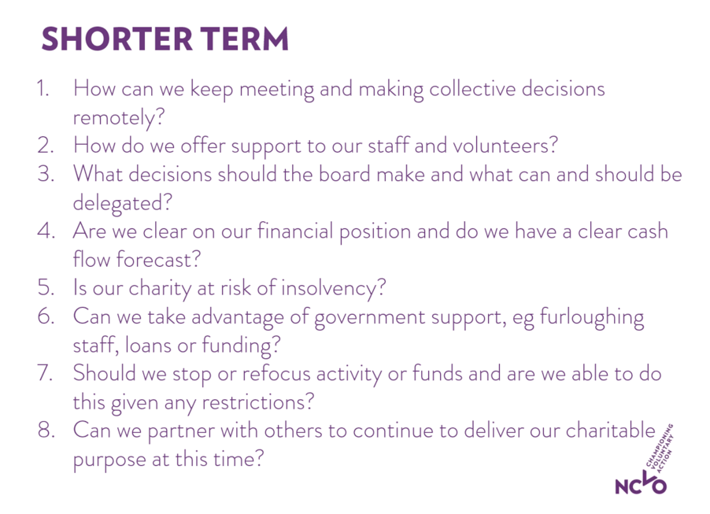
4. Short and medium term planning guidance.

Slides from NCVO’s ‘Governing during a pandemic’ webinar
https://www.youtube.com/watch?v=34H_b2MtNxc

‘Assessing risks in uncertain times’, Zurich Insurance, webinar,
May 20th
‘Making decisions in tough times’ webinar on June 11th
can be registered for on NCVO’s website
‘Recovery Planning’ London Plus/London Funders 21.5.20

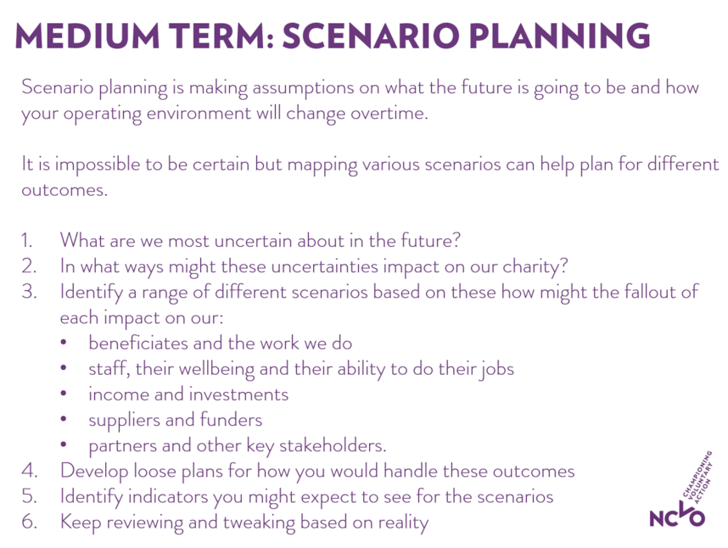

External economic environment: Consider four broad phases:

Phase 1: ‘whatever it takes’ – expansion of Government spend

Phase 2: staged withdrawal of spend

Phase 3: stimulus – defeating fear

Phase 4: restructuring and rebuilding

5. SWOT analysis w/c 4.5.20

1.Strengths | 2.Weaknesses
3.Threats | 4.Opportunites

6. Funders
6.1 Government funding
Government funding for the sector is £750m for covid and post-covid relief, split into:
The National Lottery to administer half, prioritising local delivery of covid relief by small charities
Individual departments to target education, domestic violence and abuse, modern day slavery, homelessness etc.
Government funding will support its existing Civil Society Strategy with an emphasis on funding digital https://www.gov.uk/government/publications/civil-society-strategy-building-a-future-that-works-for-everyone

The Government’s job Retention Scheme lasts to the end of October.
https://www.gov.uk/government/publications/coronavirus-job-retention-scheme-step-by-step-guide-for-employers

6.2 Trust funding
Over 250 of the largest funders for London and beyond have pledged to:
Continue grant funding and be flexible about activities being adapted; timeframes and reporting; repurposing funds and being responsive to other adjustments grantees would like to make.
https://londonfunders.org.uk/about/covid-19

6.3 Local authority funding
As they are entirely focused on public health delivery for the foreseeable future, there is little broader information available about what their funding relationship will be with the sector. Any advice and information will be on the Department’s website, Local Government Association website https://www.local.gov.uk/our-support/lga-covid-19-support-offer and London Councils website: https://www.londoncouncils.gov.uk

LBC continues to support the Farm and has not indicated that any Strategic Partnerships are under threat.

6.4 General advice to funders
In addition to the above, funders are being urged by several bodies including New Philanthropy Capital to work jointly with each other to streamline the application and reporting processes and make a greater impact together. They are also being urged to not become solely Covid funders and to continue to support other causes. However, with the emphasis for many funders on making an impact on the public health emergency and its fallout, and to cut their financial risk, single year funding may replace multi-year awards.

6.5 Farm funding
All our funders have received an update outlining our response planning and have either confirmed continued support or not indicated that they want more information or to terminate the grant. As some are also members of London Funders, they have pro-actively got in touch to confirm their support until the situation becomes clearer, with City Bridge Trust making a donation (not a grant) of £10,350.

All our impact reports are up to date and social media and crowdfunder comments are being collected. The bid tracker which shows the progress of bid applications, reporting deadlines and funding prospects will be updated shortly.

7. Social Farms and Gardens members are
- offering timed slots for household site visits
- selling veg boxes/ plants /produce online and in person (through timed slots)
- support packages: cooking produce and partnering with other organisations to deliver locally
- running online cooking sessions using the ingredients sent in support packages which also include recipes
- growing kits: seeds and compost delivered to people isolating or seeds and instructions sent by post
- running exercise videos for families; zoom yoga sessions
- phoning vulnerable service users and sending them cards
- offering craft activities to download and share pix when completed
- offering downloads and contact information for national nature campaigns eg butterfly, hedgehog counts
- linking to competitions eg Jack Petchey photography competition
- creating what’s app account for children’s weekend playscheme (goes via parent’s account)
- arranging free grazing for horses (& transport) via the Countryside Alliance.[Vauxhall City Farm]
- [Pre Covid offer at Hackney] livestock are on rotation with a Kent farm
- Taking part in the 2.6 challenge: (https://www.twopointsixchallenge.co.uk); people taking part in challenges in their home (like Tom Moore’s) on behalf of farms; staff running events on the farm eg lamas’ laps
- Moving their Corporate offer online: virtual ‘meet the animals’ http://stepneycityfarm.org/at-the-farm/whats-on
- Asking online shoppers to name the Farm as beneficiaries when they shop; Amazon wish lists button
- Asking supporters to lobby on their behalf with local and central government

8. Some considerations adapted from New Philanthropy Capital
consider:
- positioning the Farm as essential (rather than ‘nice to have’) for LBC to deliver specifics for residents, contrasting with charities which will be demanding their help.
- using LBC’s knowledge of emerging needs to focus on specific groups eg BAME refugees/asylum seekers or care leavers’ transition to independent living through mentoring life skills such as budgeting and cooking sessions
- repurposing some site areas: eg a small group/individual researchers using part of the gardens for ecological/biodiversity trials
- asking our major donor and corporates who have offered their business expertise for risk management/planning advice
- new Covid funding opportunities, (depending on decisions about mission)
- how to further utilise our London-wide area of benefit both within and beyond the Social Farms and Gardens network

9. Employment risks advice
- Covid Recover Strategy, gov.uk
- Peninsula peninsulagrouplimited.com
- Managing risk and risk assessment at work, HSE, HSE.gov.uk
- Free 30 minute consultation with HR employment expert, Bates Wells, BatesWells.co.uk
- Croner: unlimited free access to their HR and Employment Law helpline Croner.co.uk
- HR Net, Cranfield Trust, free charity consultancy https://www.cranfieldtrust.org/pages/11-hrnet

Angela Routley
angela@ktcityfarm.org.uk
May 18, 2020

