Case Study: Tremains Woodland Rangers
Brackla, Bridgend March 2020

Background
Tremains Woodland Rangers is a volunteer community group who are working to manage their local woodland and to hold informal and formal community woodland events for all ages. Some of the trees are over 300 years old and the Tremains Woodland is an ancient semi natural woodland. The site gained nature reserve status in 2008 and the Council owned and managed the woodland until early 2019 when the Tremains Woodland Rangers formed and began working alongside the Council in managing the site. Since then the group have sort to tackle fly tipping and invasive species and is now working to mark out a better network of footpaths. The group are ably led by Mark Payn, who is a long-standing local resident and has a passion to improve the safety, biodiversity and sustainability of the woodland, having used it extensively for play time as a child.
The Rangers group have been active through the winter - Coppicing and path marking. A map of proposed paths and improvements has been drawn up and displayed at one of the entrances to the woodland. Over the next few months the aim is to improve the path access in all areas to make it easy and safe for everyone to use.
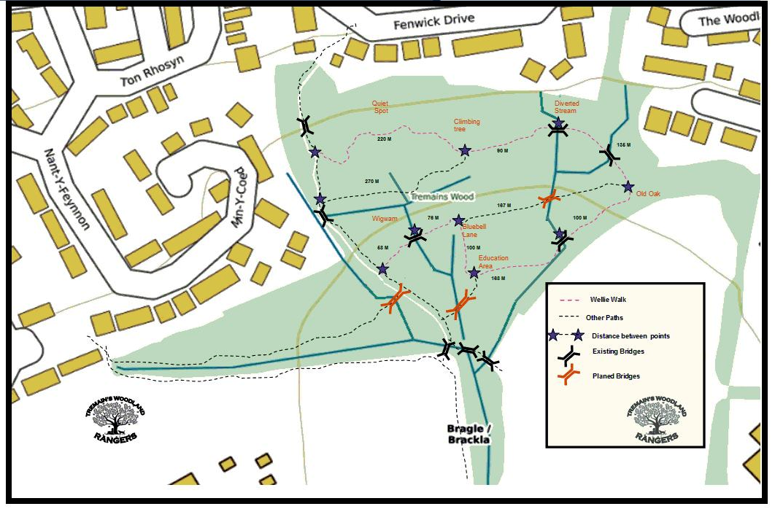
Main audience and volunteers
The group currently have 9 keen volunteer members who carry out work at the woodland and help to host organisations like Llaisygoedwig, Wildlife Trusts Wales, the local scouts, mental health groups and primary schools who enjoy the use of the small outdoor education space. The local Rugby club have also helped out at the woodland and the local GP surgery are keen to do more social prescribing at the woodland. The Rangers have made a great effort to link up with all members and groups in the local community.
Achievements
Since the beginning of 2019 the group have constituted and achieved a huge amount in a short space of time. The group have mapped, marked out and measured all the existing and proposed paths. They have created an informal education area and sort the advice of the local tree officer to see what trees need maintenance and cutting back. As well as increasing the network of paths, Tremains Woodland Rangers are working to increase light into the woodland to improve the biodiversity and different types of species. This is all being done in a sensitive and sustainable manner taking on board expert advice. The Rangers have recently found rare types of fungi.
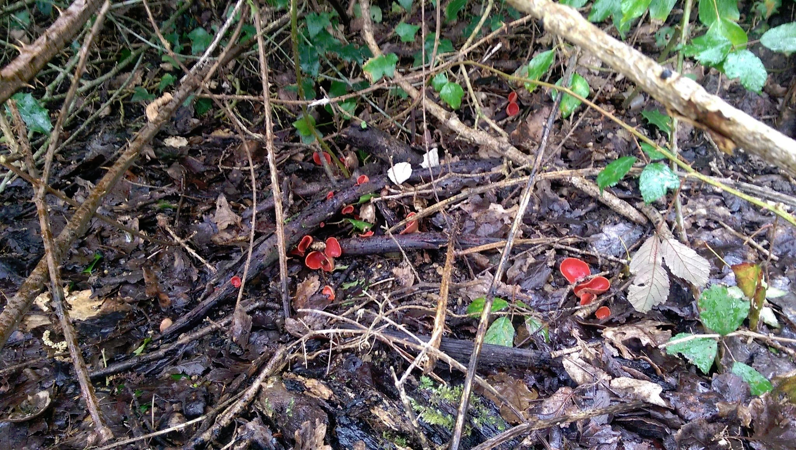
Scarlet Elf Cups
The group have moved and repaired some of the bridges whilst improving the paths and providing markers to encourage walkers.
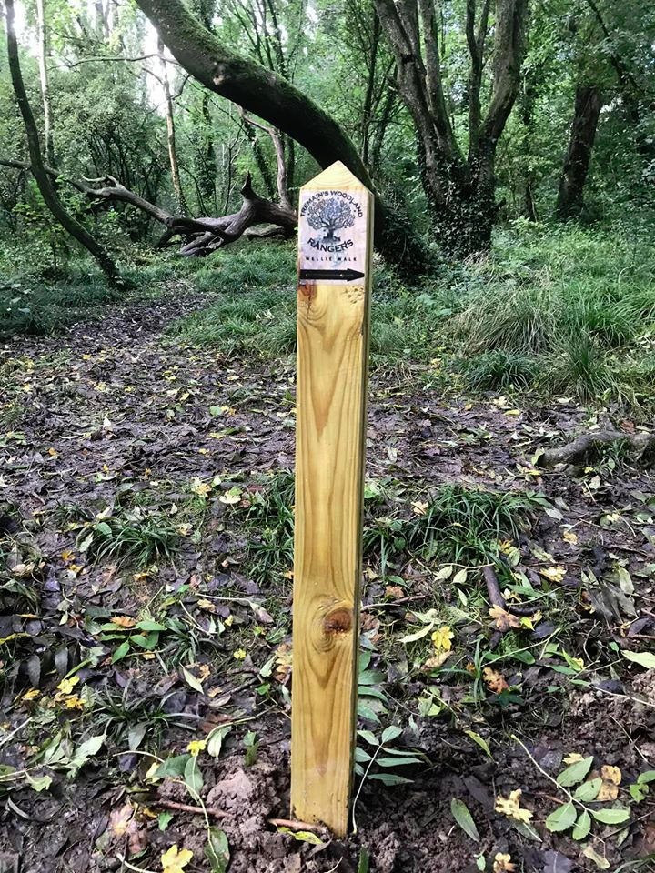

Getting permission
The group contacted Bridgend County Borough Council in early 2019 about their enthusiasm to help manage the woodland more effectively. The Council were keen to work with the group due to lack of resources to manage such sites as effectively as they would like. Showing their abilities and sustainability credentials has led to them gaining a license to occupy the woodland alongside the Council as landlord.

The Future
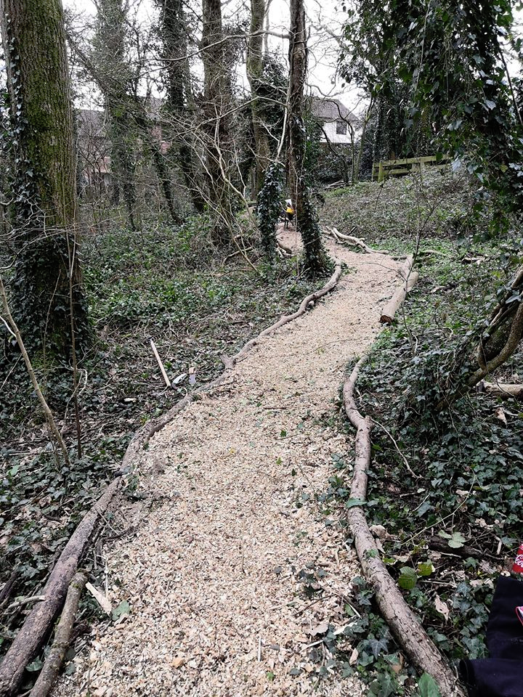

The Tremains Woodland Rangers are keen to sure up their network of paths and hope to have a grand opening of the new path network later this year. Hopefully all the planned improvements will be done in time to achieve a Green Flag Community Award in 2021.

