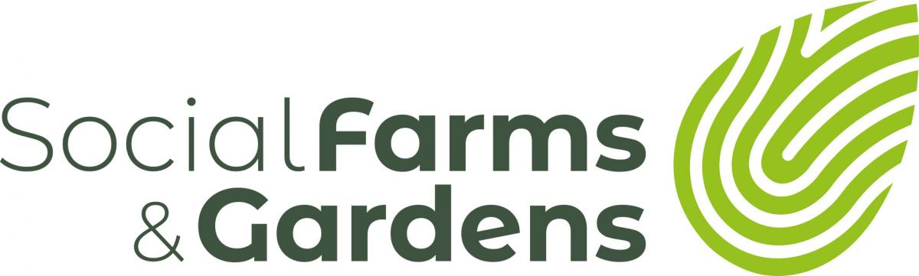

Go Compare & Duffryn Community Link
Who Is Involved?
Gocompare.com is a British financial services comparison website, established in Wales in 2006. It provides comparison details for vehicle, home and pet insurance, breakdown cover, utilities, financial products, etc. www.gocompare.com
Duffryn Community Link is an organisation that makes connections to wider policy agendas for the improvement of local people’s quality of life; at the same time as securing the involvement and empowerment of local residents to be in control of the solutions to the needs, problems and opportunities experienced by the community. One of their projects is a community allotment to promote healthy eating, living and well-being.
www.duffryncomlink.org.uk
How did the relationship begin?
In 2013, Bob Barry and Jane Lewis from Duffryn Community Link sent an email to Nadine Beaton, Development and Engagement Manager at Gocompare to introduce the community group to the company.
What attracted Gocompare to this project?
While Gocompare is a well-known brand, it employs fewer than 200 people and is based less than half a mile from Duffryn, a large housing estate in the southwest of the city of Newport. The local link is really important as it allows staff to witness the need they are addressing as well as the impact their input makes.
Gocompare employees know that the Duffryn estate is an area of high deprivation and that there is great need in the community. As a small, local project, Gocompare know that the money and resources they put in, however small, will make a real difference to DCL and the work they do. There is also potential for scalability, during busy business periods, community work needs to take a back seat and not so many resources are available but in quieter times, the company know they can be more involved.
Quality
From the initial introductory email that led to a meeting between Gocompare and Duffryn Community Link, the company were always aware of the quality of the work achieved by the community group. Gocompare receive numerous enquiries from charities seeking support and not all can be met, Duffryn stood out for the quality and professionalism with how it approached Gocompare and its core work in the community.
Jane and Bob always feed back to Nadine to tell her how the resources/people they provided have made a difference.
Personality
A strong working relationship between Nadine, Bob and Jane with mutual understanding has been essential for the relationship to flourish. Ongoing communication is open and frequent. DCL will often proactively approach Nadine with ideas of how the company could be involved in an activity from donating £15 for wrapping paper to releasing 12 members of staff to repaint the group’s offices.
However, on one occasion, Nadine challenged Bob and Jane to think BIG. What would they ask for if they could have anything – while starting small they were pushed to think bigger, and assessing their needs decided that a minibus would be a really useful investment. This would allow them to do more excursions and visits with the community that had been impossible due to prohibitive travel costs. They didn’t really expect it to happen, but Nadine knew her colleagues and knew they were competitive. There commenced a huge fundraising operation around Gocompare staff and throughout their supply chain and other local businesses resulting in a cheque for £15,000 for a new minibus! Not only has this result been the pinnacle of the relationship for both sides, it also generated positive press coverage in the local area.
“See the Difference”
Being local and proactive means that Gocompare see the impact that their donations are making on the people supported by DCL. For example, the company sponsored an ice rink at the nearby Celtic Manor Hotel which allowed their staff discounted entry. Rather than using it themselves, they donated the tickets to DCL and funded transport so that local children who had never been to the impressive hotel were able to spend an evening enjoying the rink.
Why is Gocompare supporting the community?
The main driver of the activity is benevolent – supporting a grassroots charity doing great work in the local community brings a smile to the faces of employees at Go compare who get involved in the activity.
There is also an element of fun competition and encouraging staff to be the best that is good business practice. The company held a Food Festival for staff where each team was given £50 to run a stall and they had to make as much profit as possible by being innovative – “blue sky thinking” – all the profits then went to DCL’s allotment project at Tredegar House to purchase gas stoves.
But more than improving staff morale, community involvement is an opportunity for staff development. The “For the Greater Good” Charity Committee runs as a formal entity managing a budget, minuting meetings and making strategic decisions. A team of 12 staff from across the company painted the DCL offices which was a really good opportunity to build relationships between departments which can be difficult to foster in some workplaces.
The company recognises there is greater PR benefits to the relationship that aren’t currently being exploited – for both sides – and this is something Gocompare could develop.

